**Exercise 8A:** Creation of AWS Learning Account

* Anand (22BD1A6615)
* Click on “Get Started” in the email. Create an account on the AWS page.

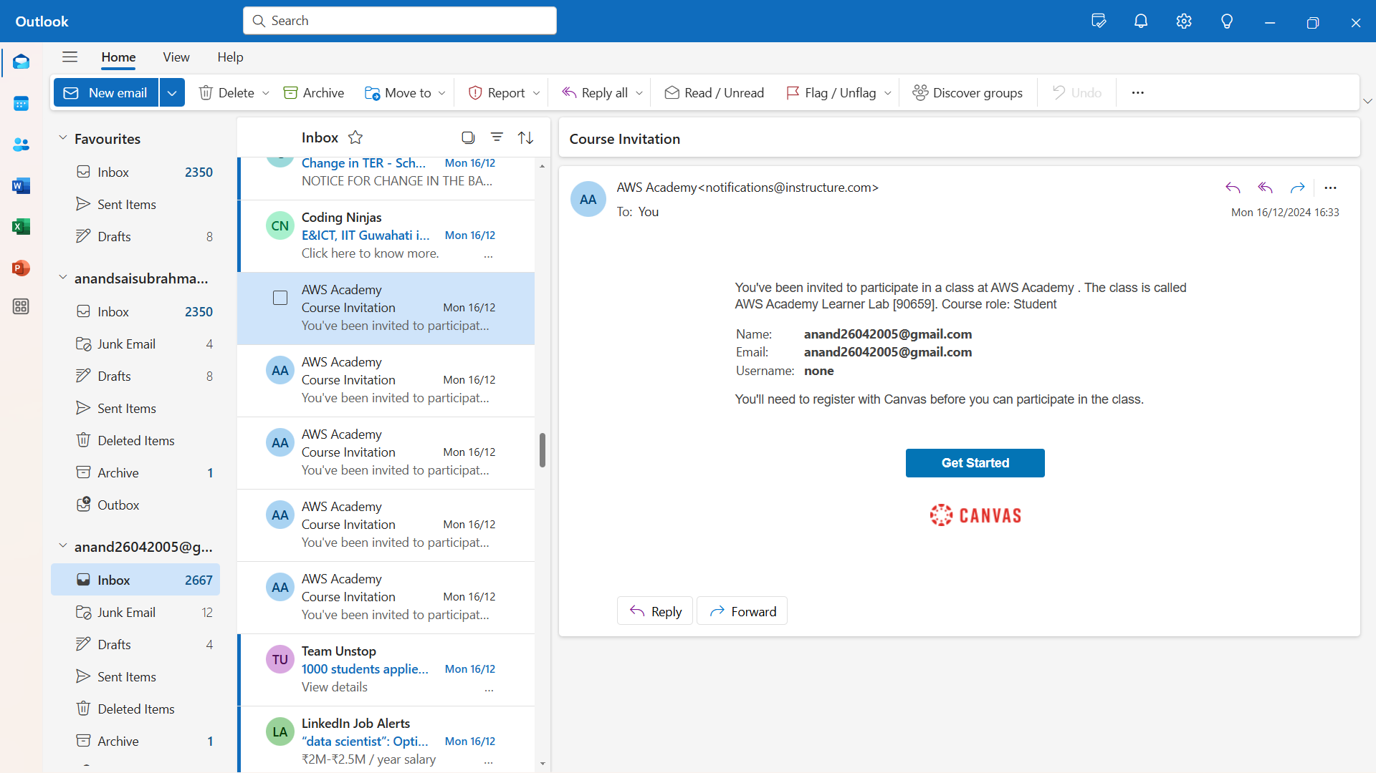

* Login with the credentials.

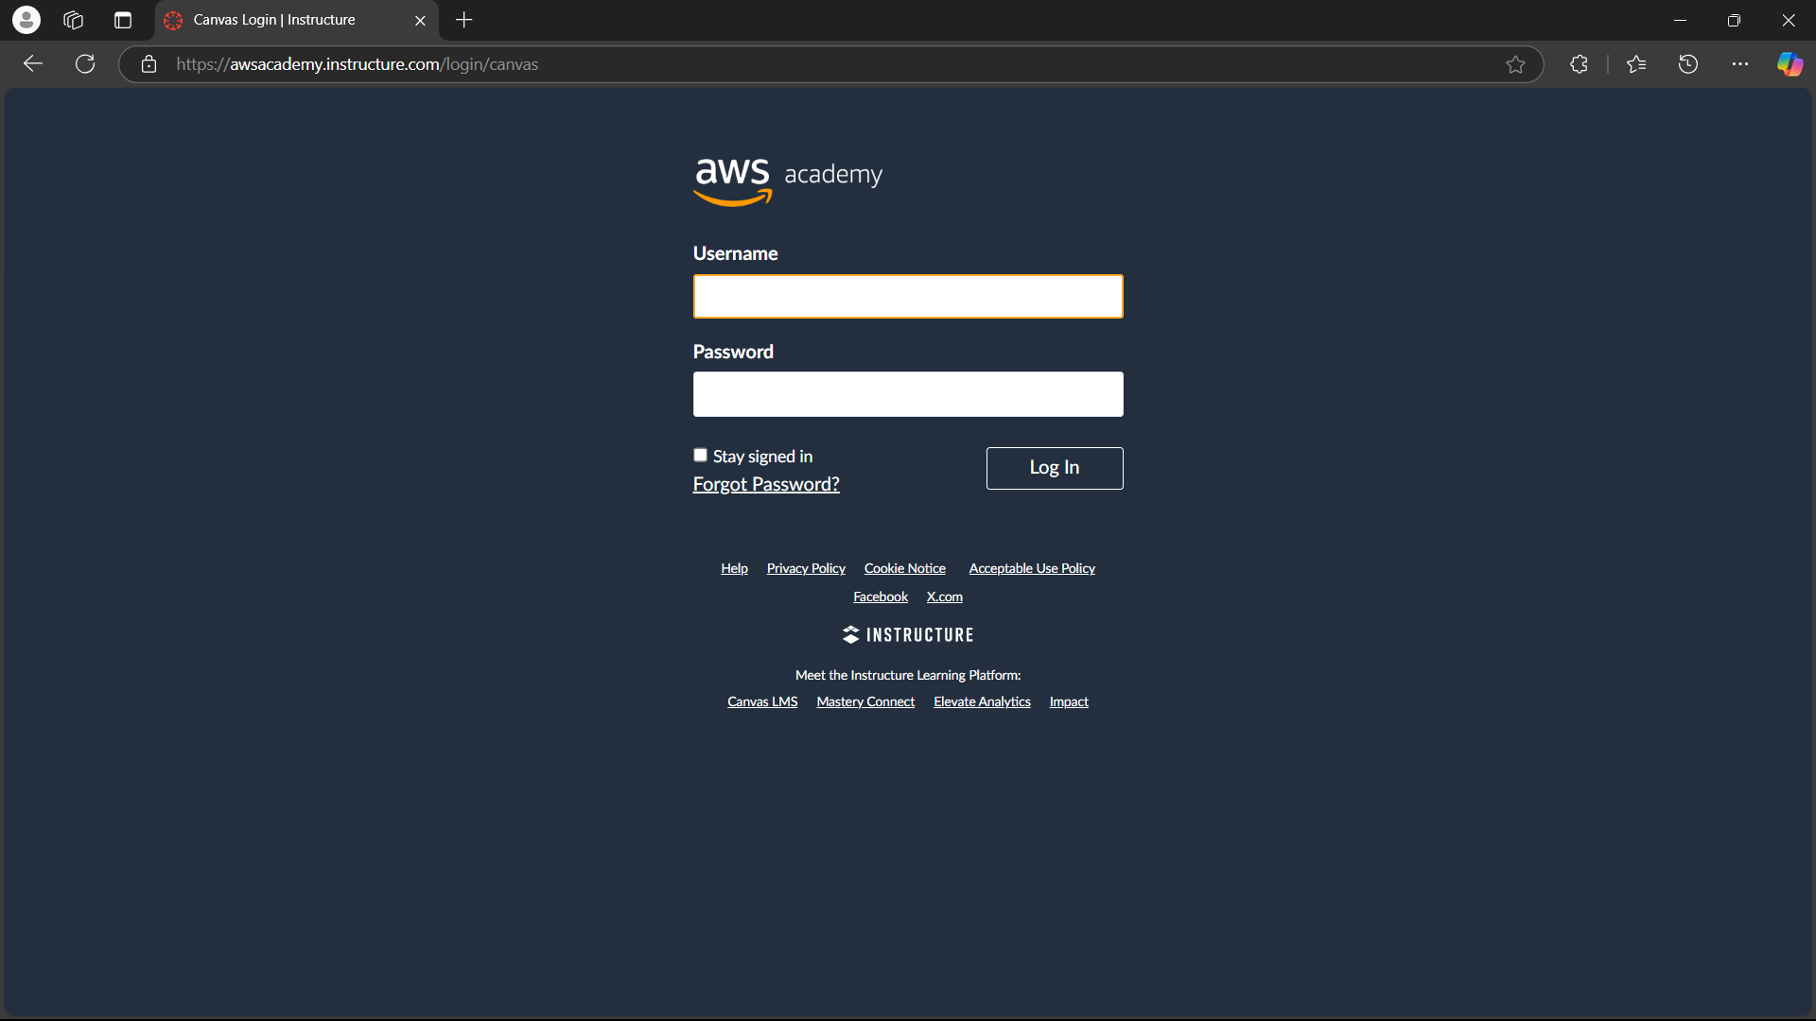

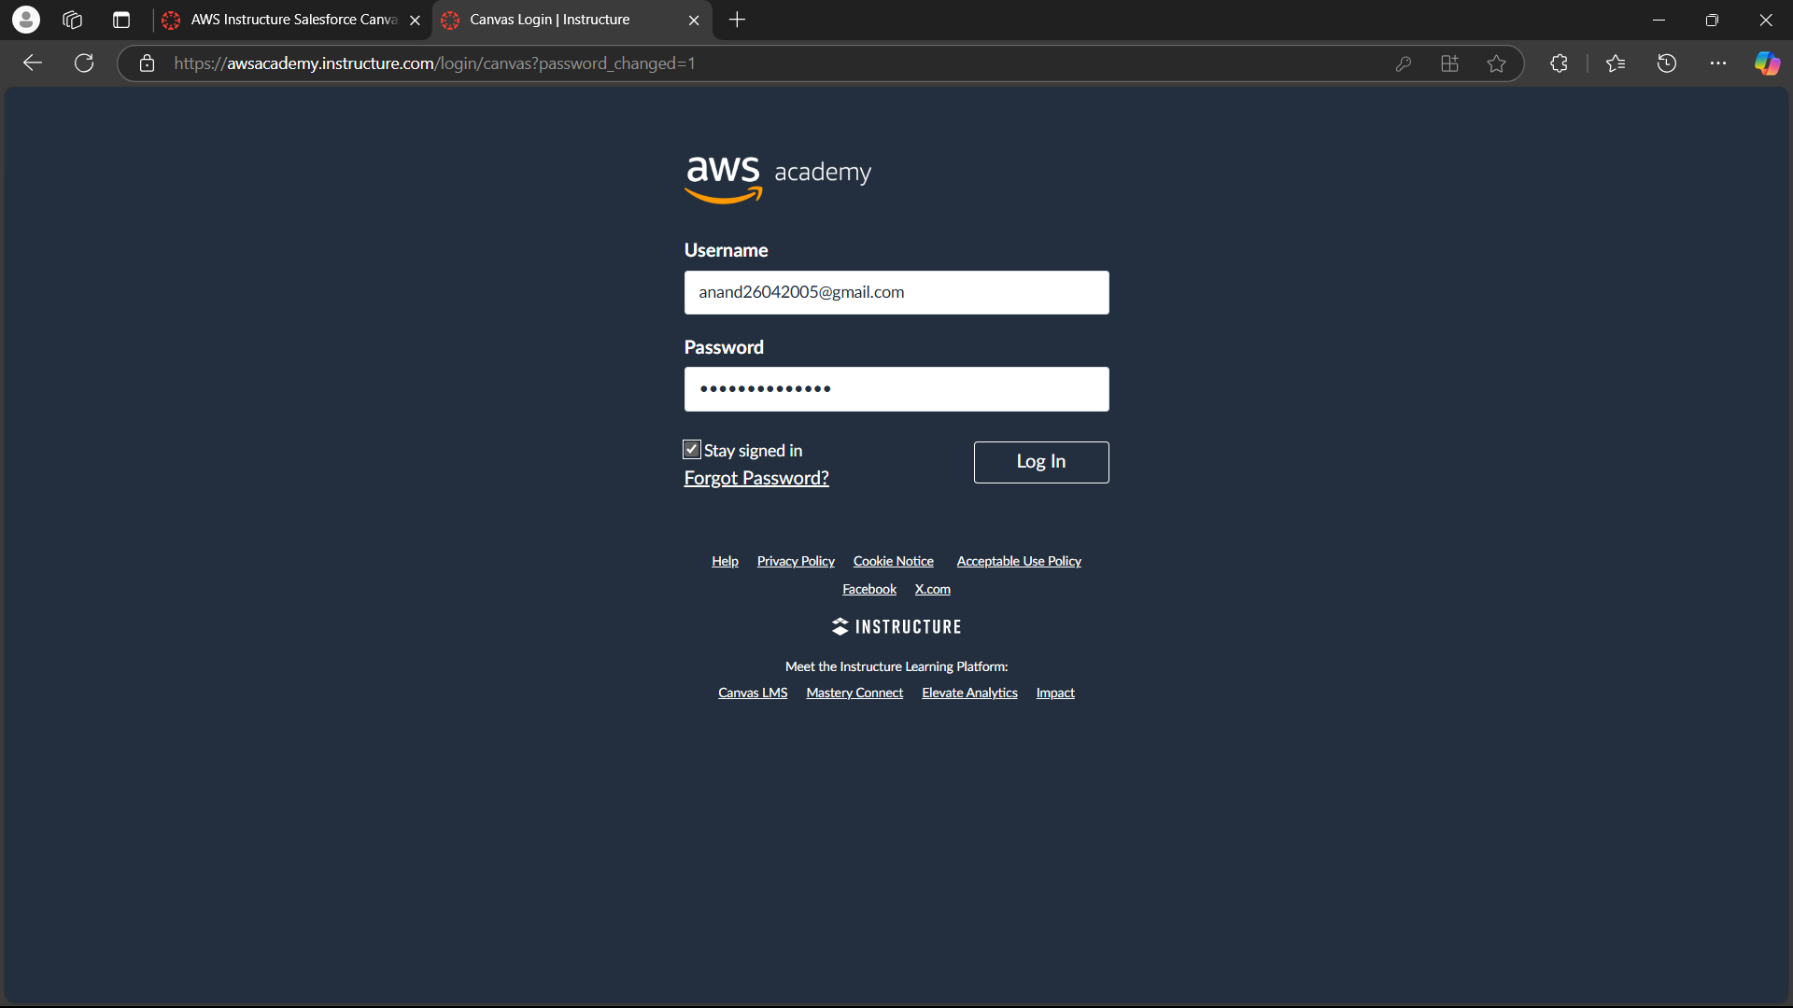

* To login again next time, search AWS Academy Login, and login with the same credentials.

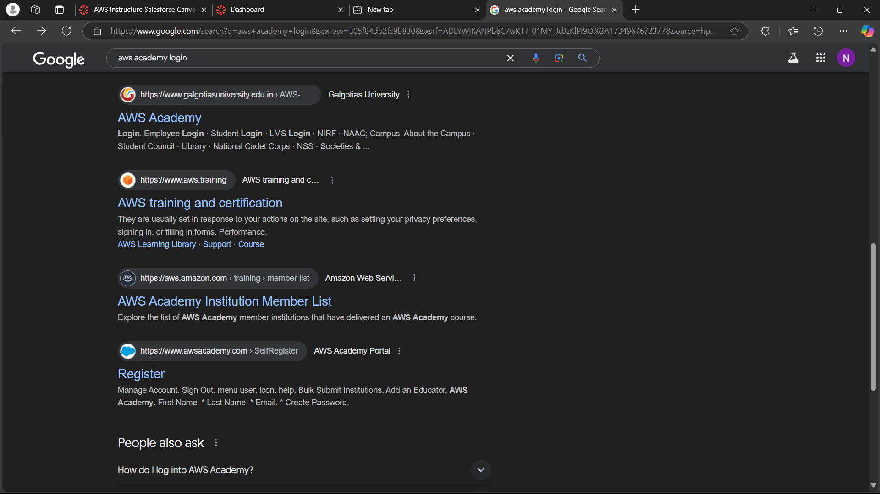

* Go to Dashboard and click on the available Lab.

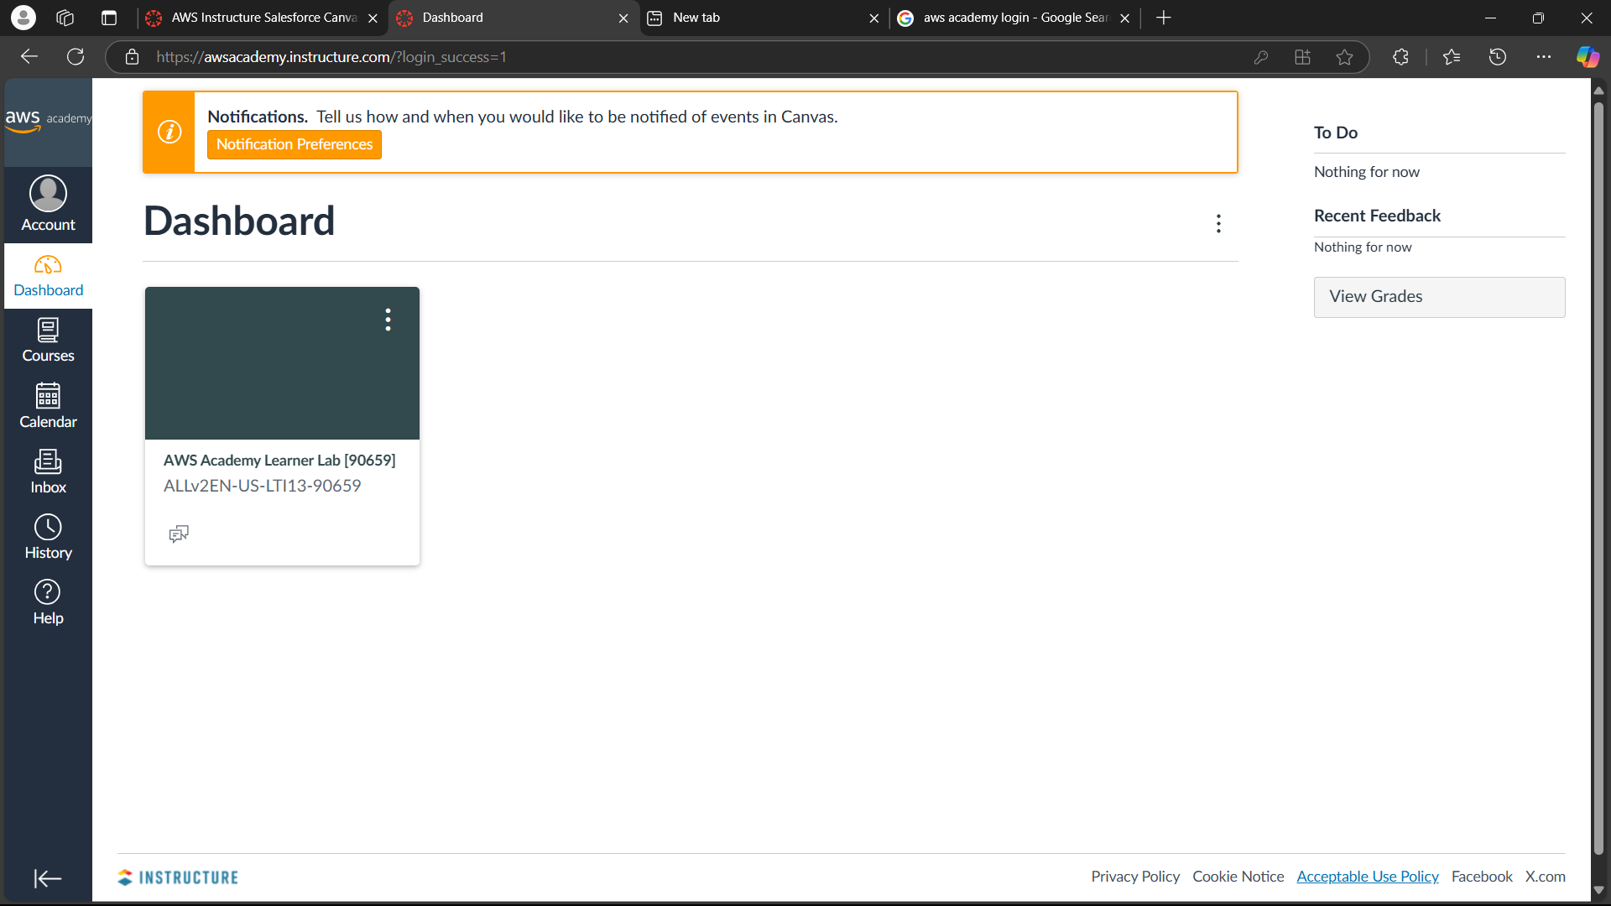

* Scroll down and click on the “Launch AWS Academy Learner Lab”

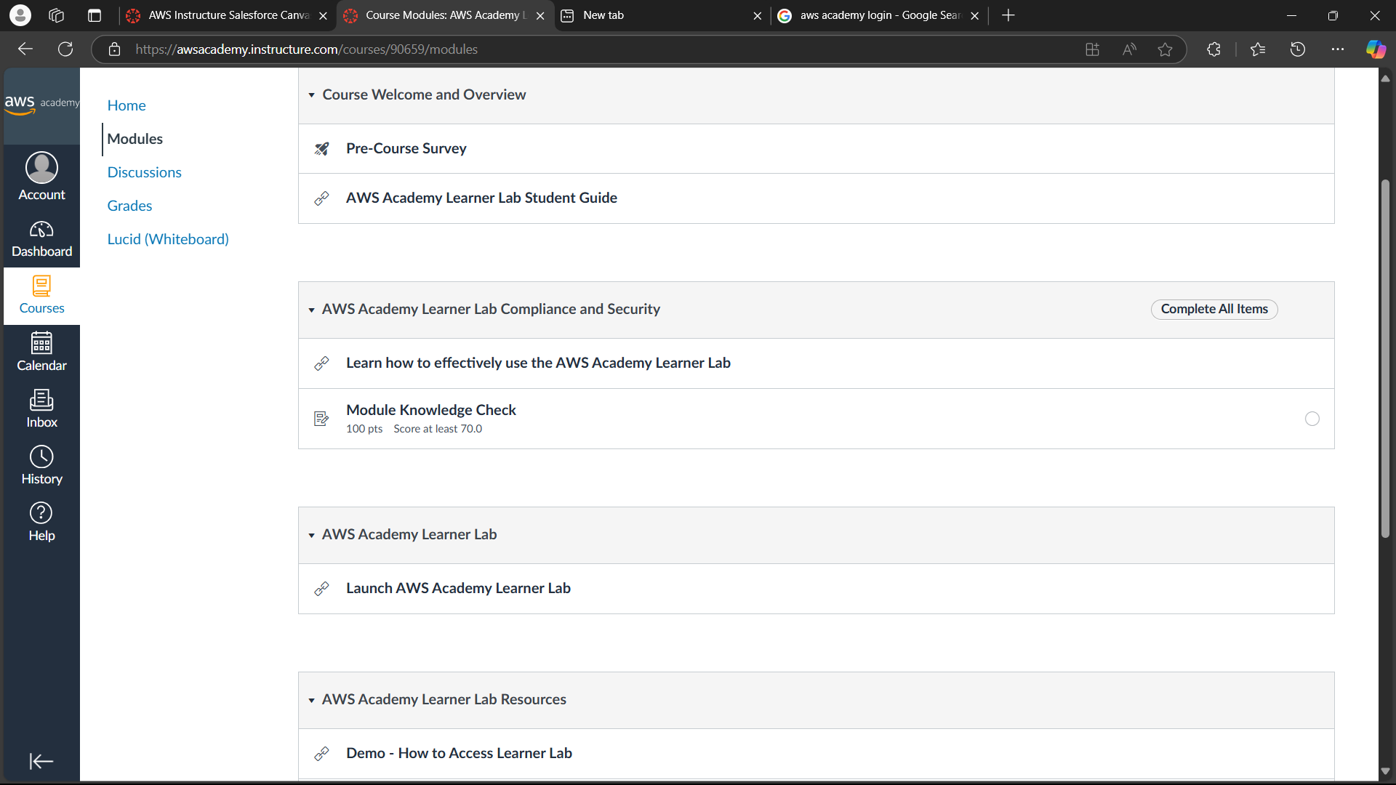

* Scroll down and click on I Agree after reading T&Cs.

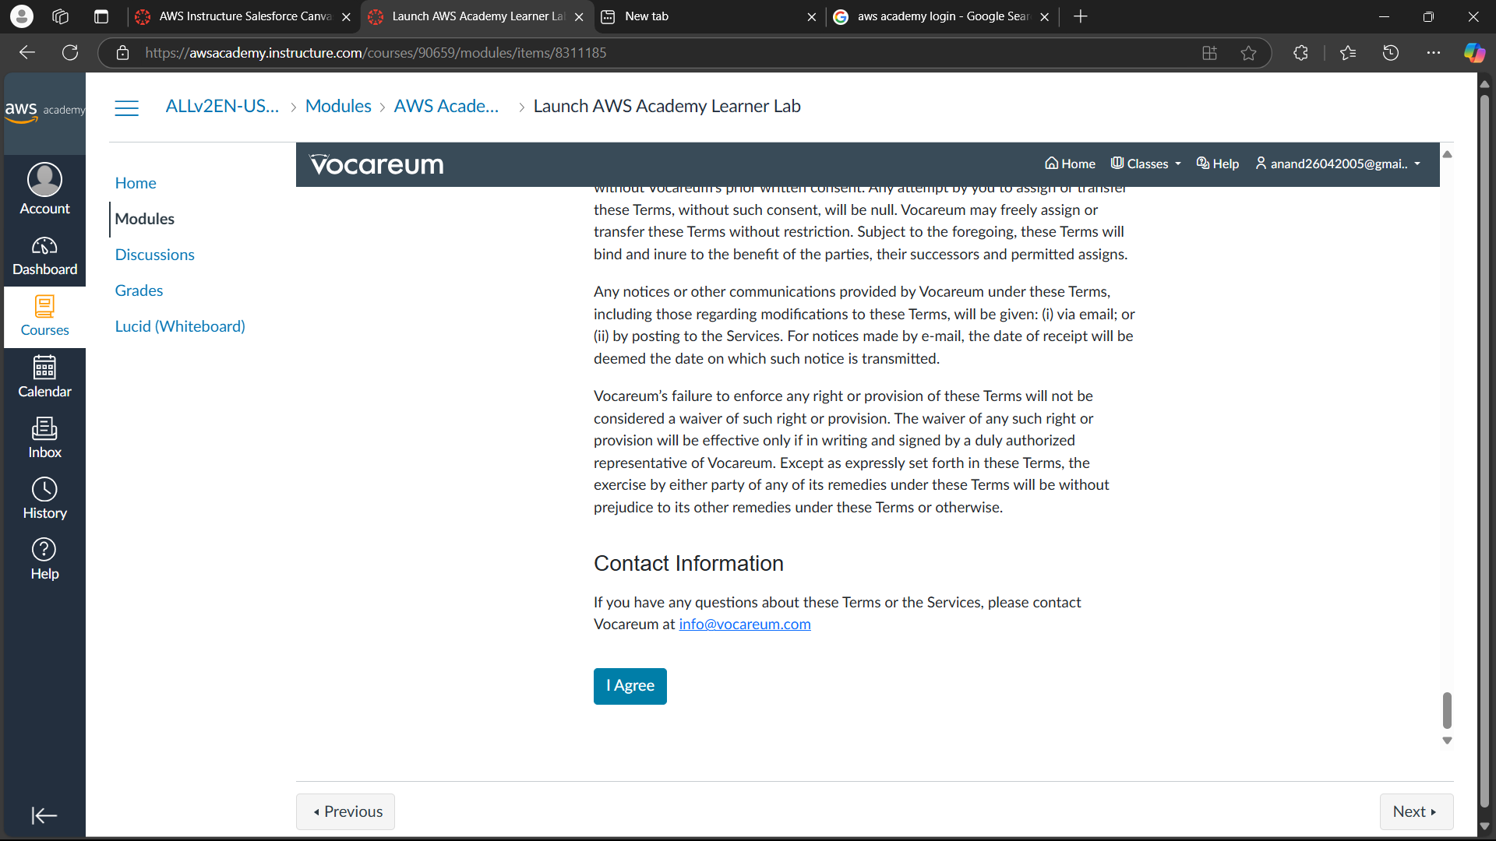

* Click on Start Lab on the next page.

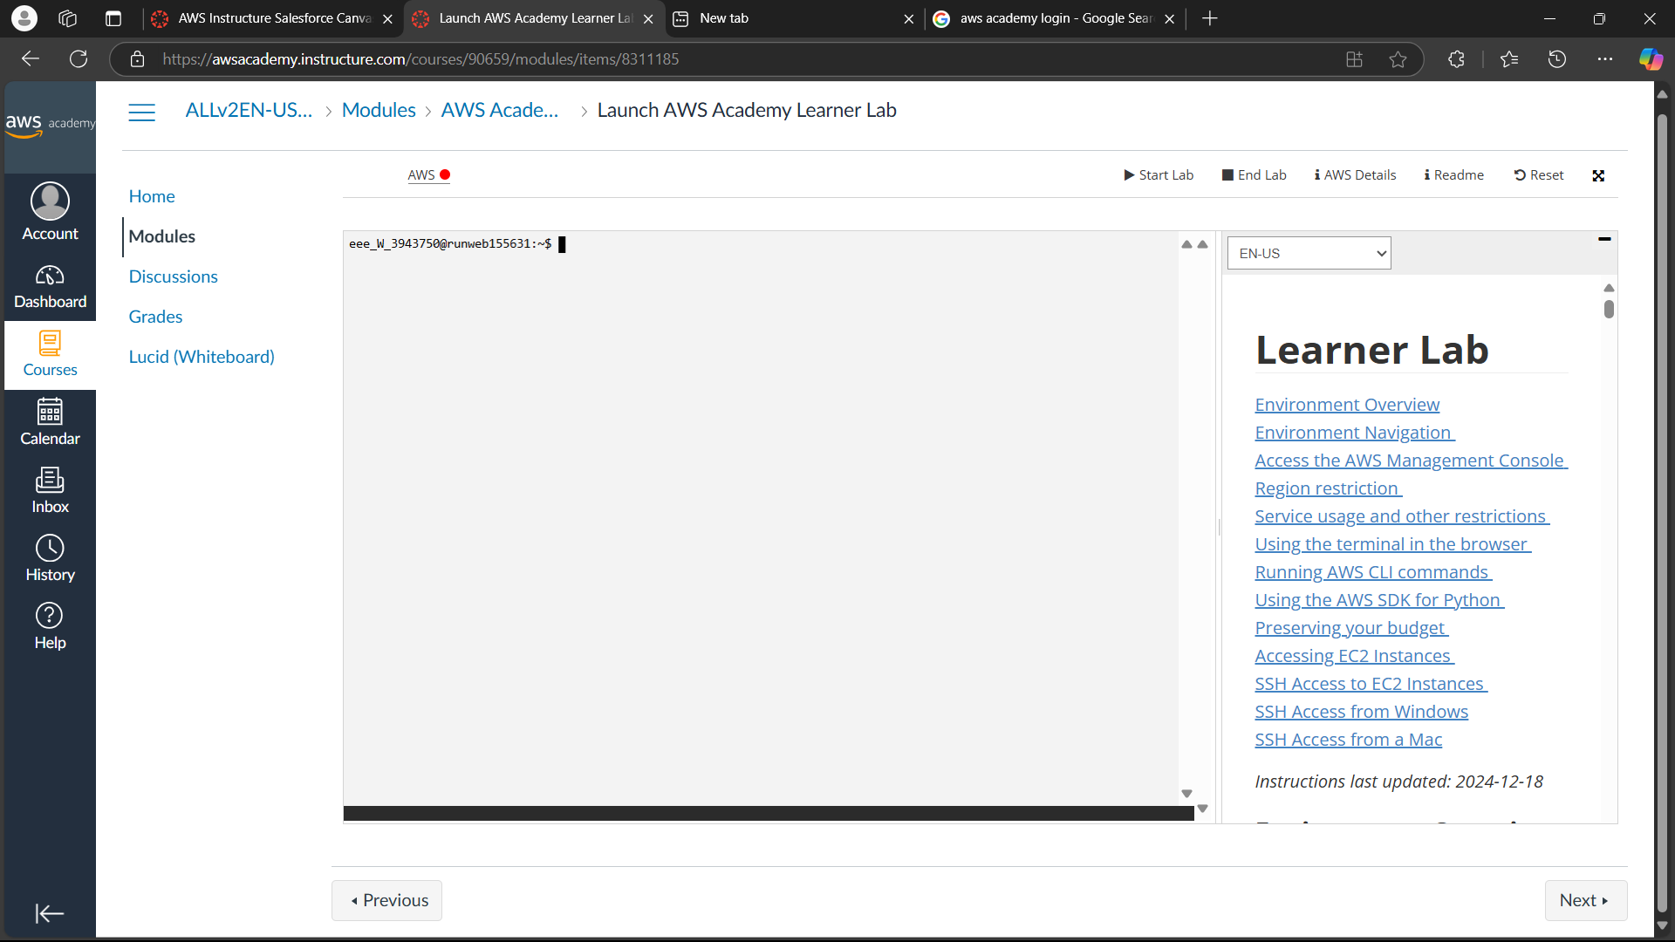

* When you see a green light, the lab is active.

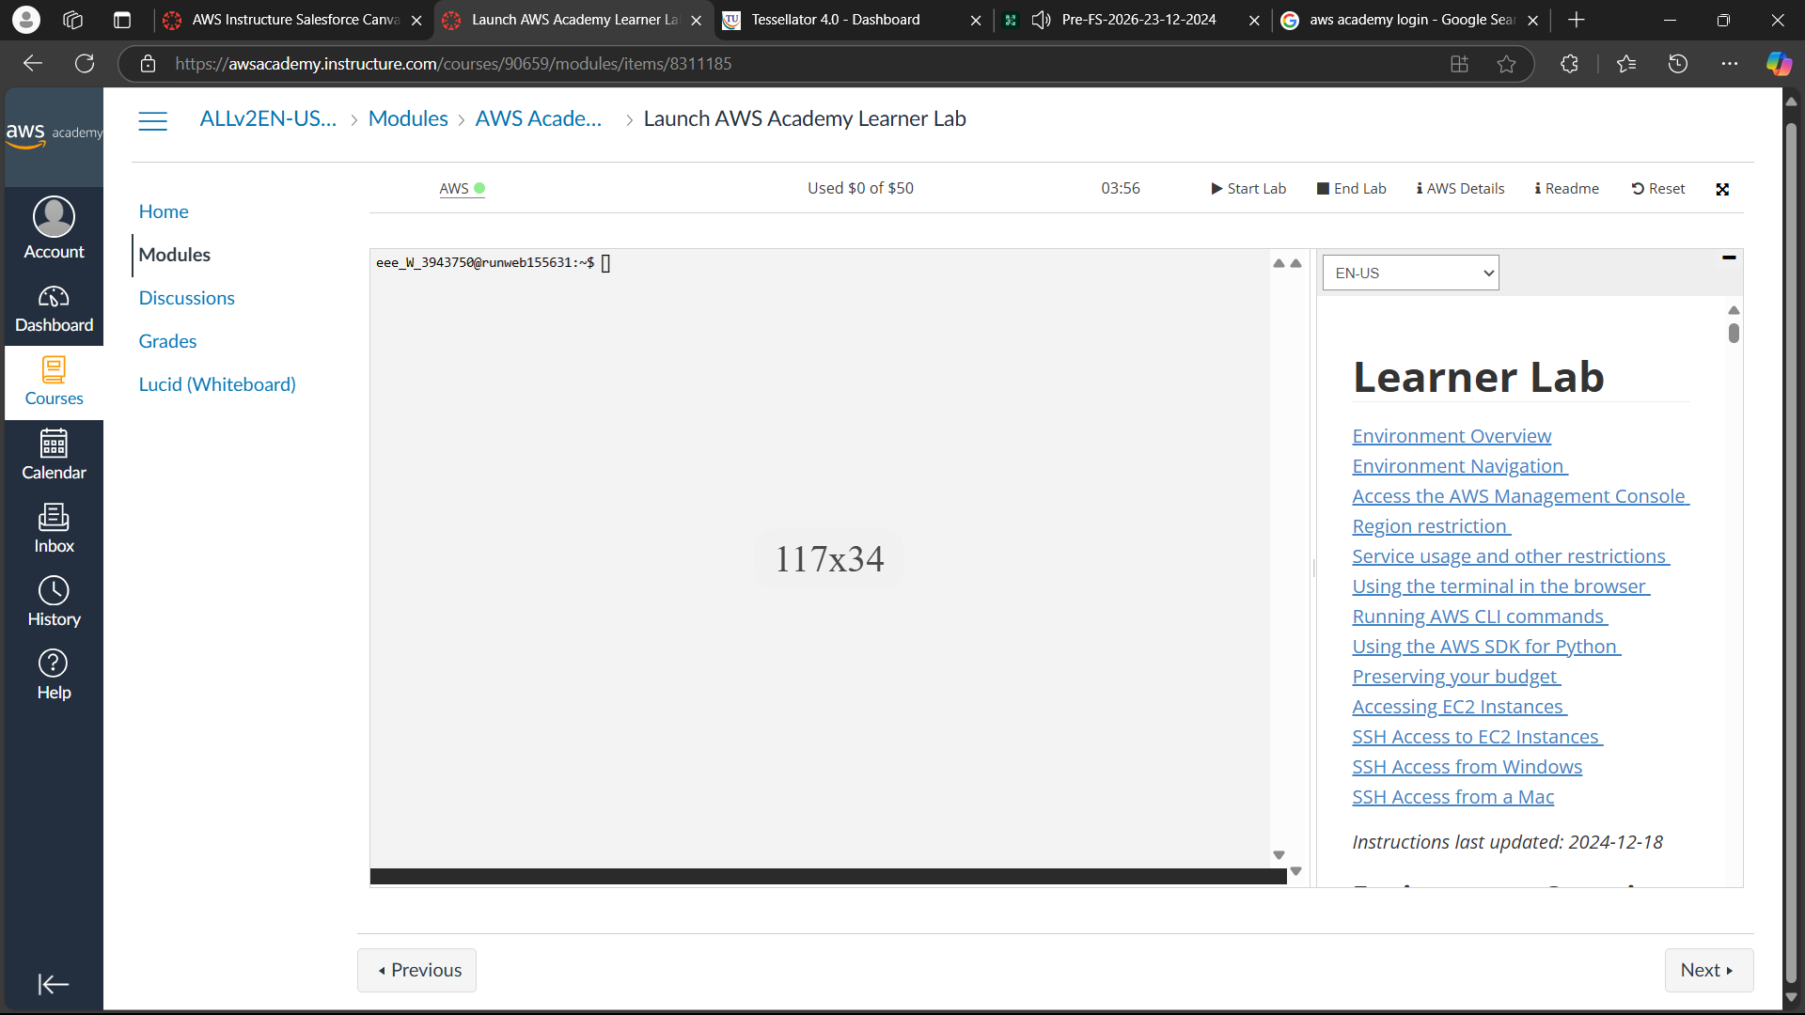

* Click on “AWS” and the AWS page appears. Click on EC2.

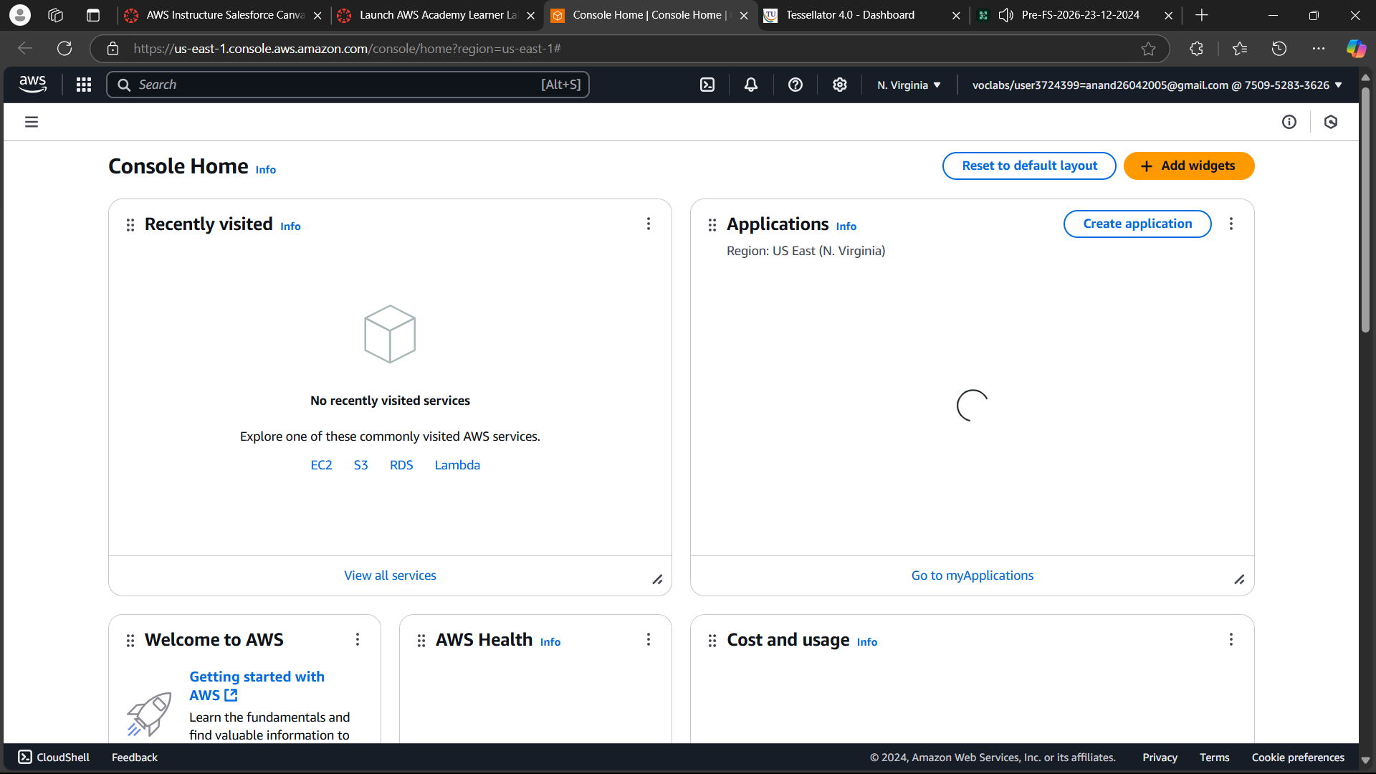

**Exercise 8B:** Project Deployment in the AWS Cloud using EC2 Instance.

* Follow the previously mentioned steps to start the Lab. Click on “Launch Instance” on the AWS page.

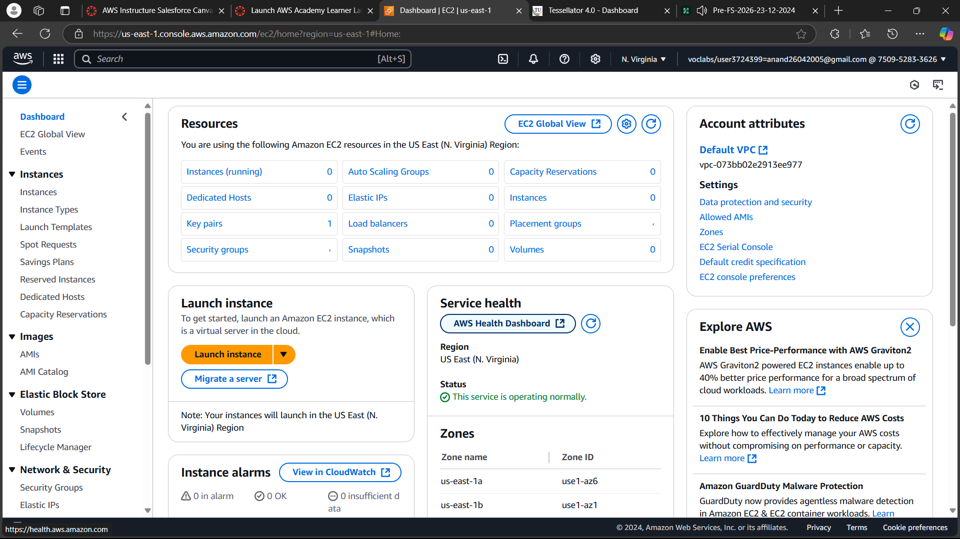

* Enter a name for the instance and click on Ubuntu in AMI.

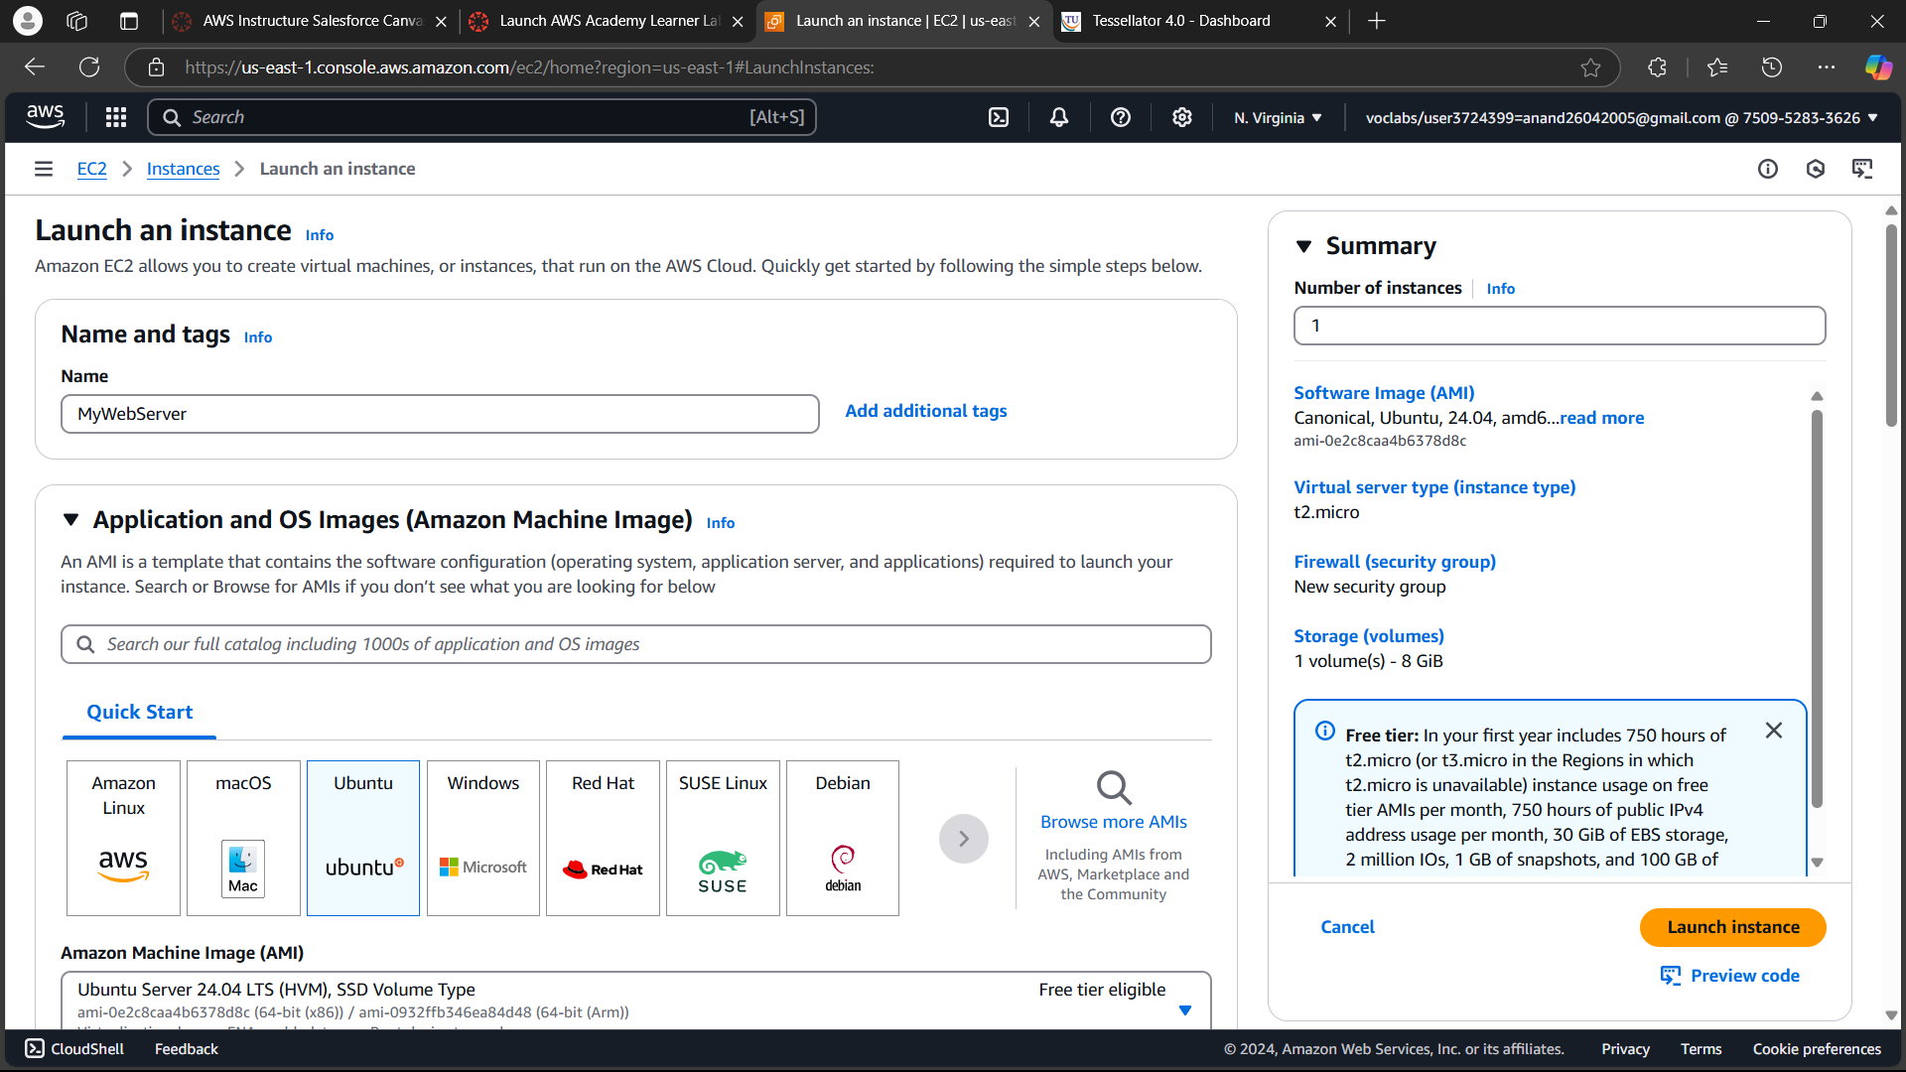

* Scroll down and create a keypair to be able to connect to instance using SSH.

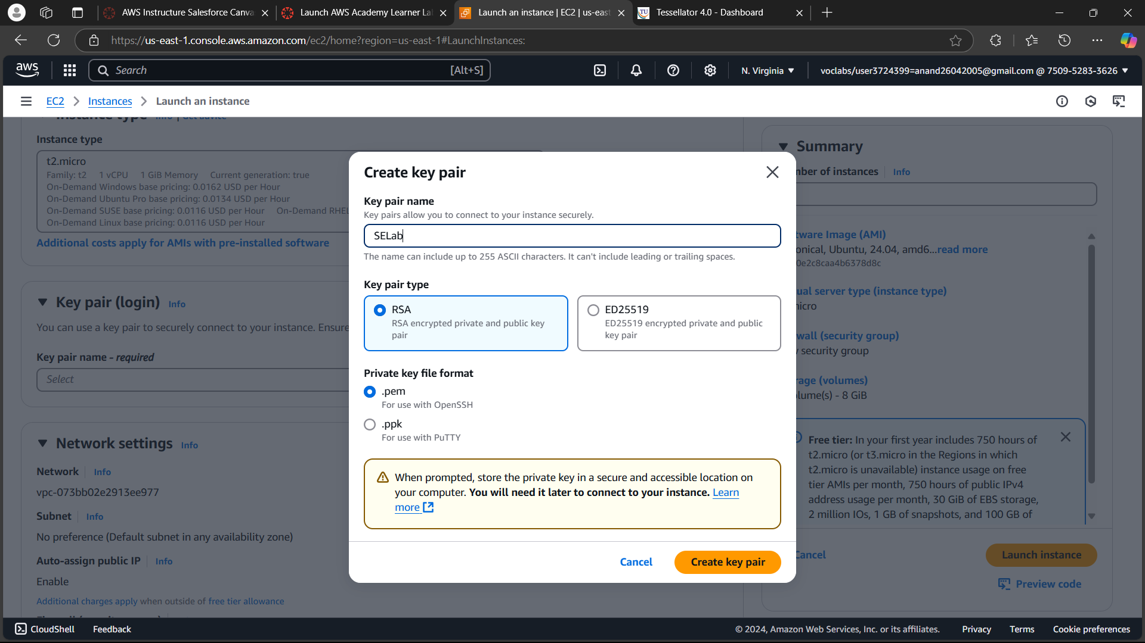

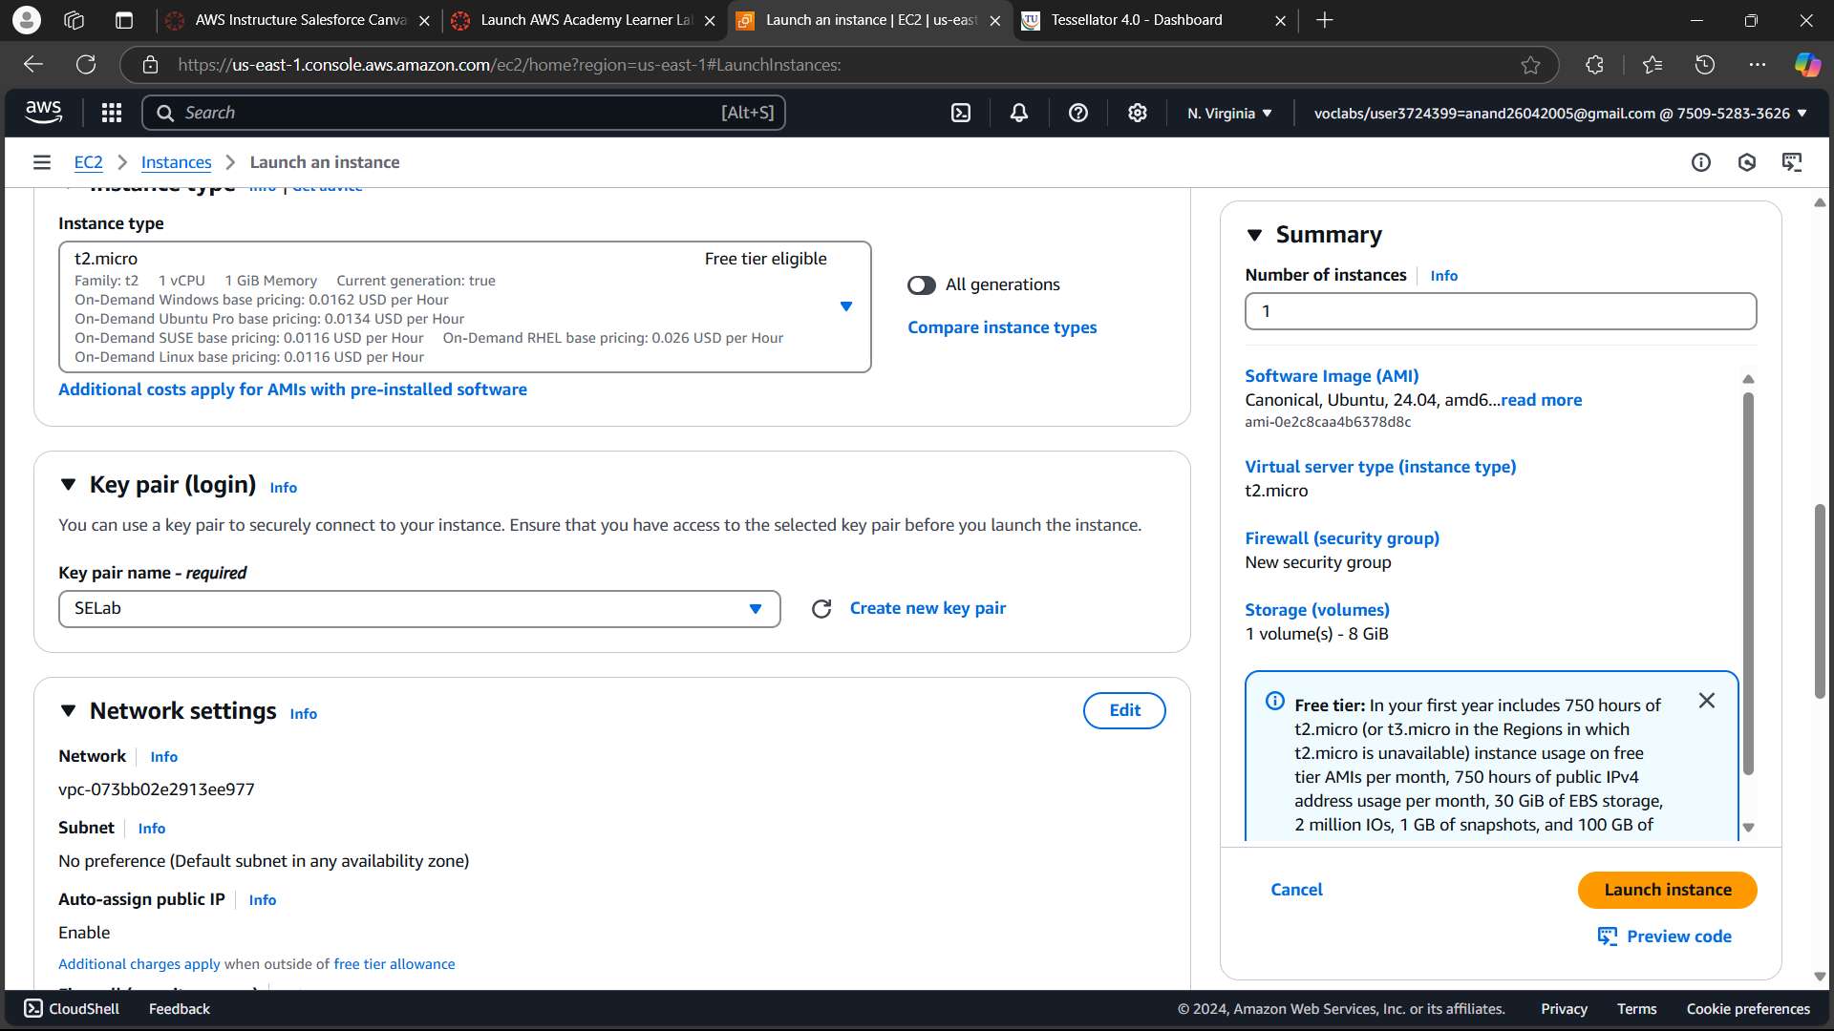

* Check the boxes for “Allow HTTP and HTTPS traffic on the internet”. Next, click on “Launch Instance”.

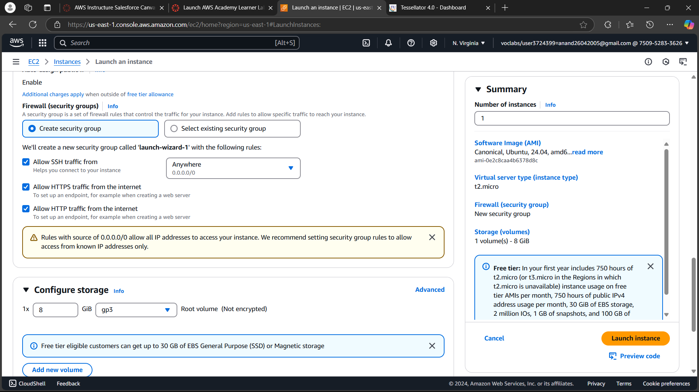

* Click on connect on the next page.

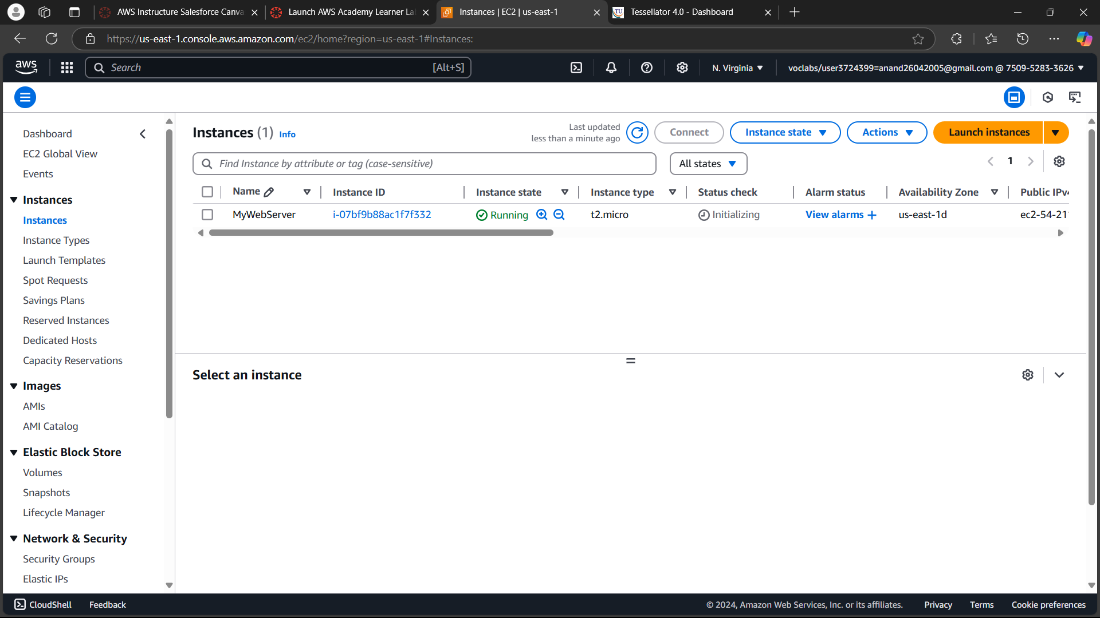

* Copy the SSH command and paste it in a new powershell window.

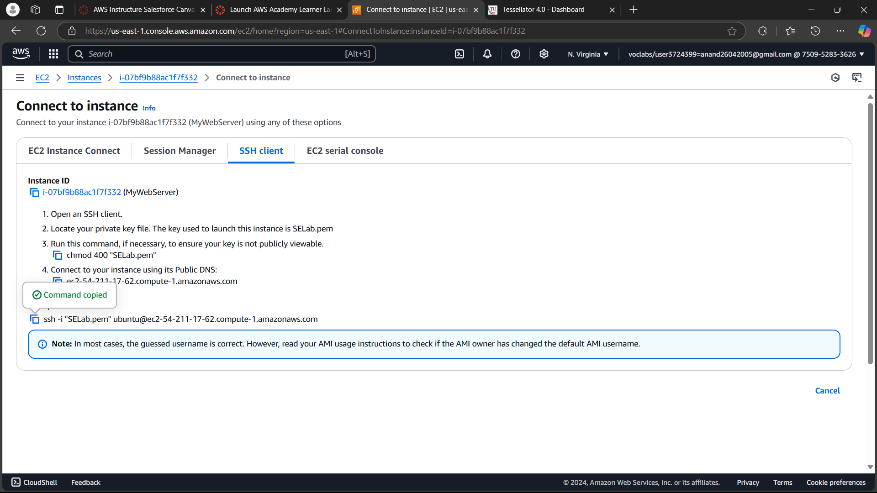

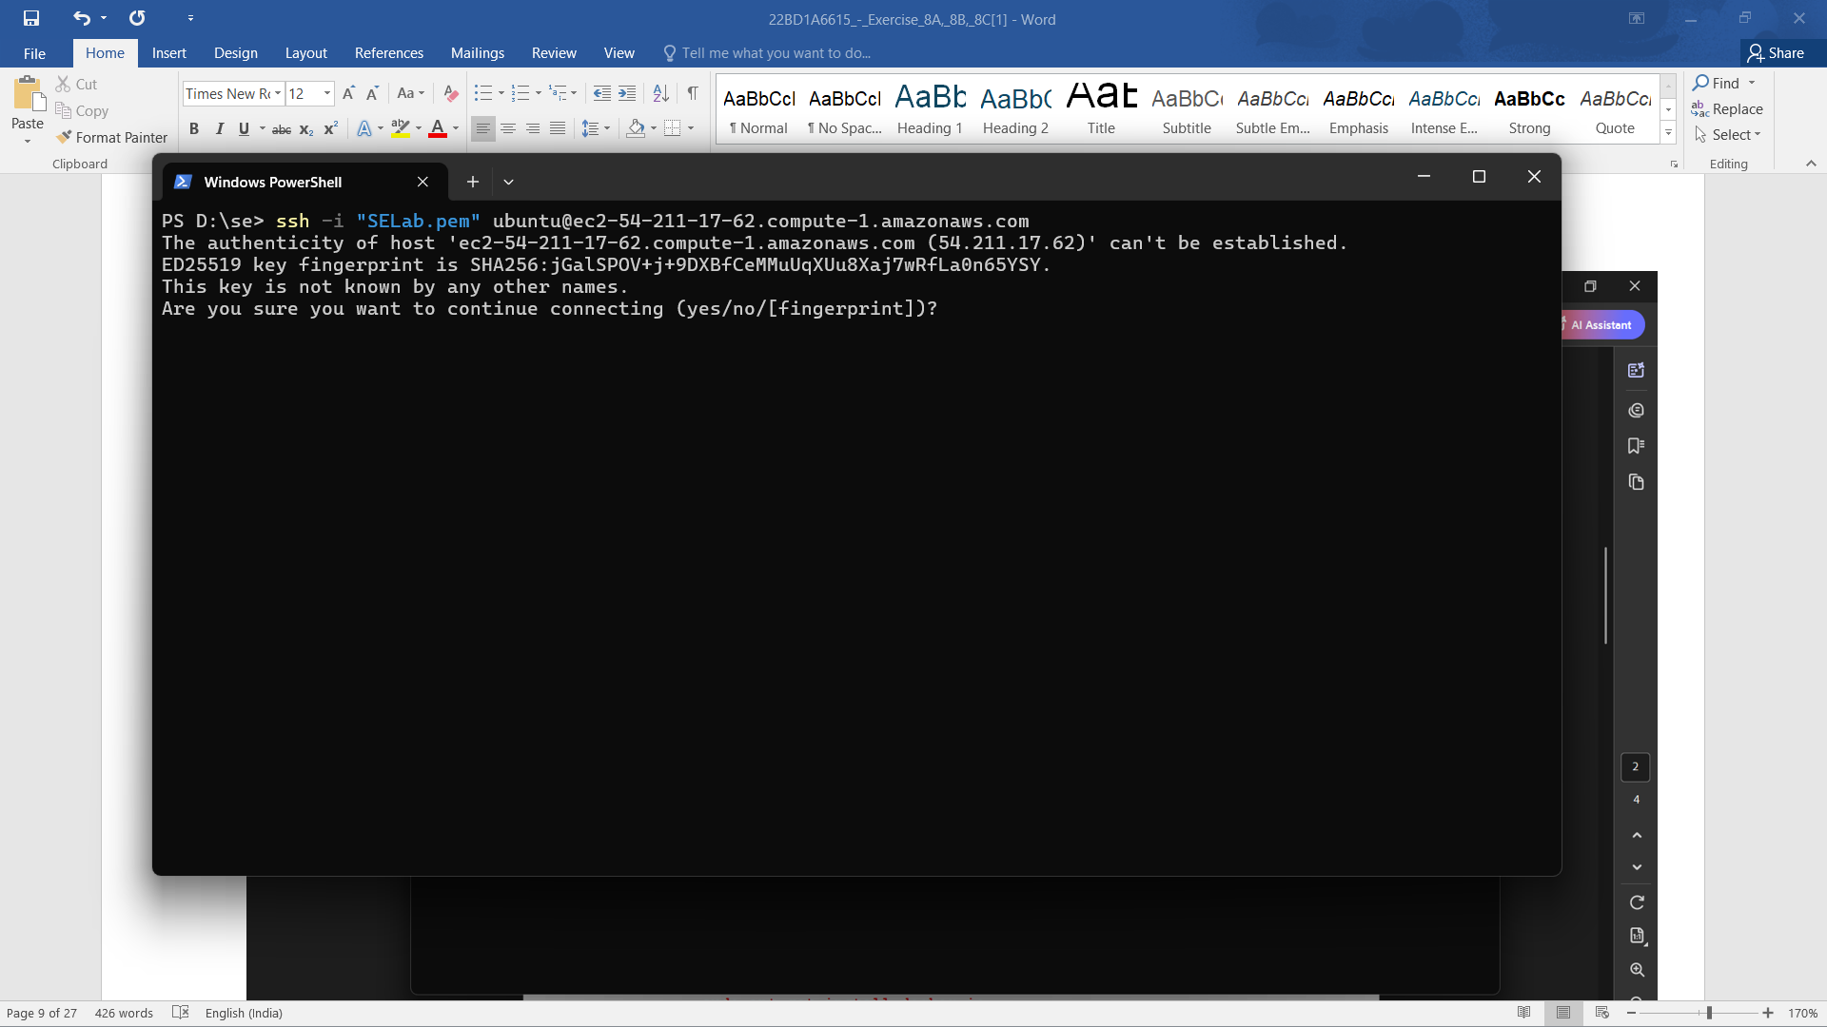

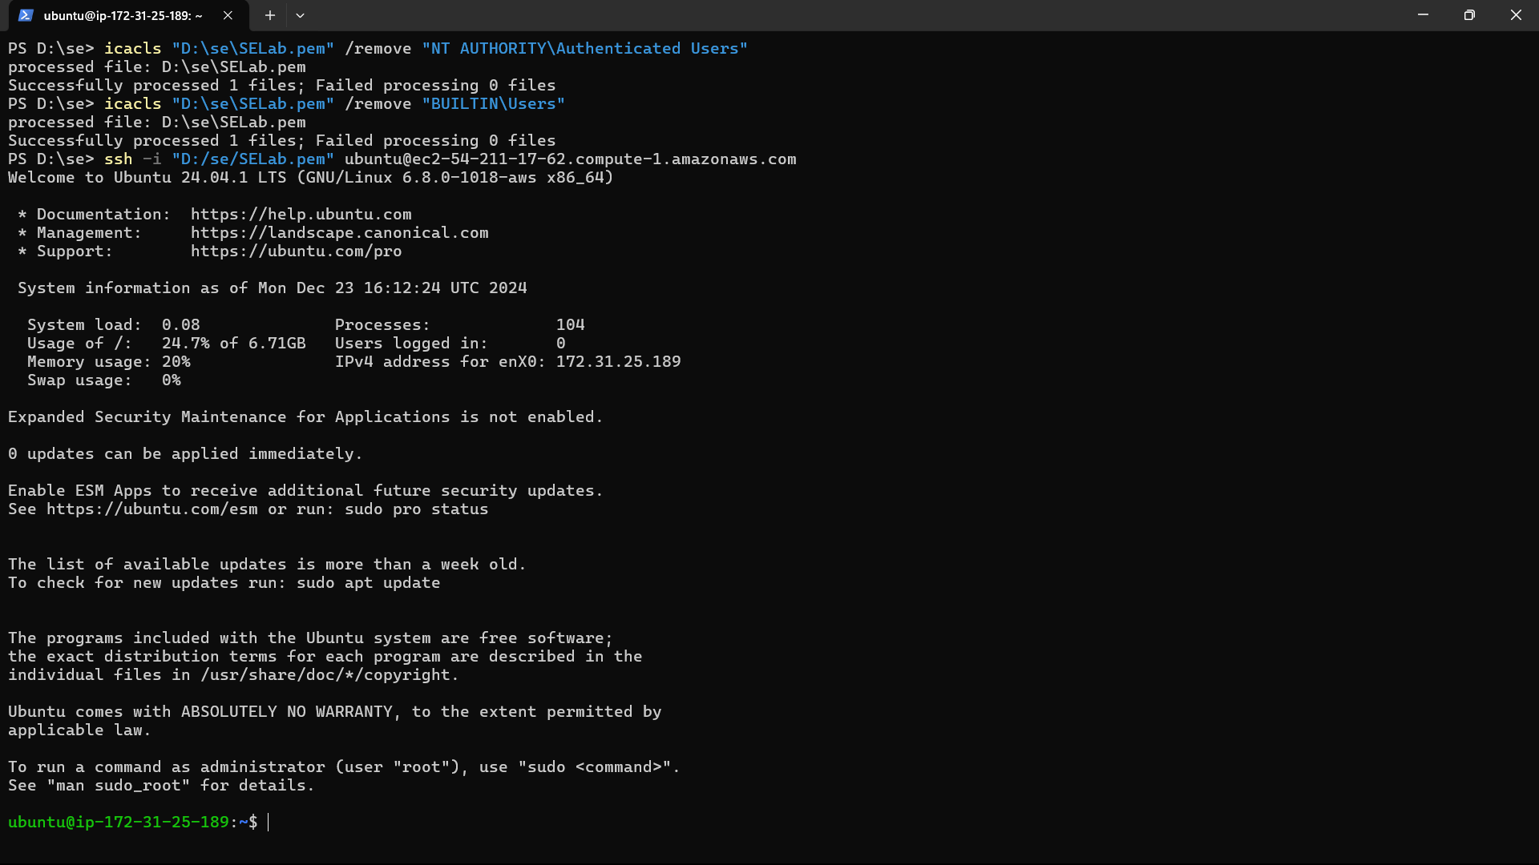

* Run sudo apt update to update the instance, and run the following commands.

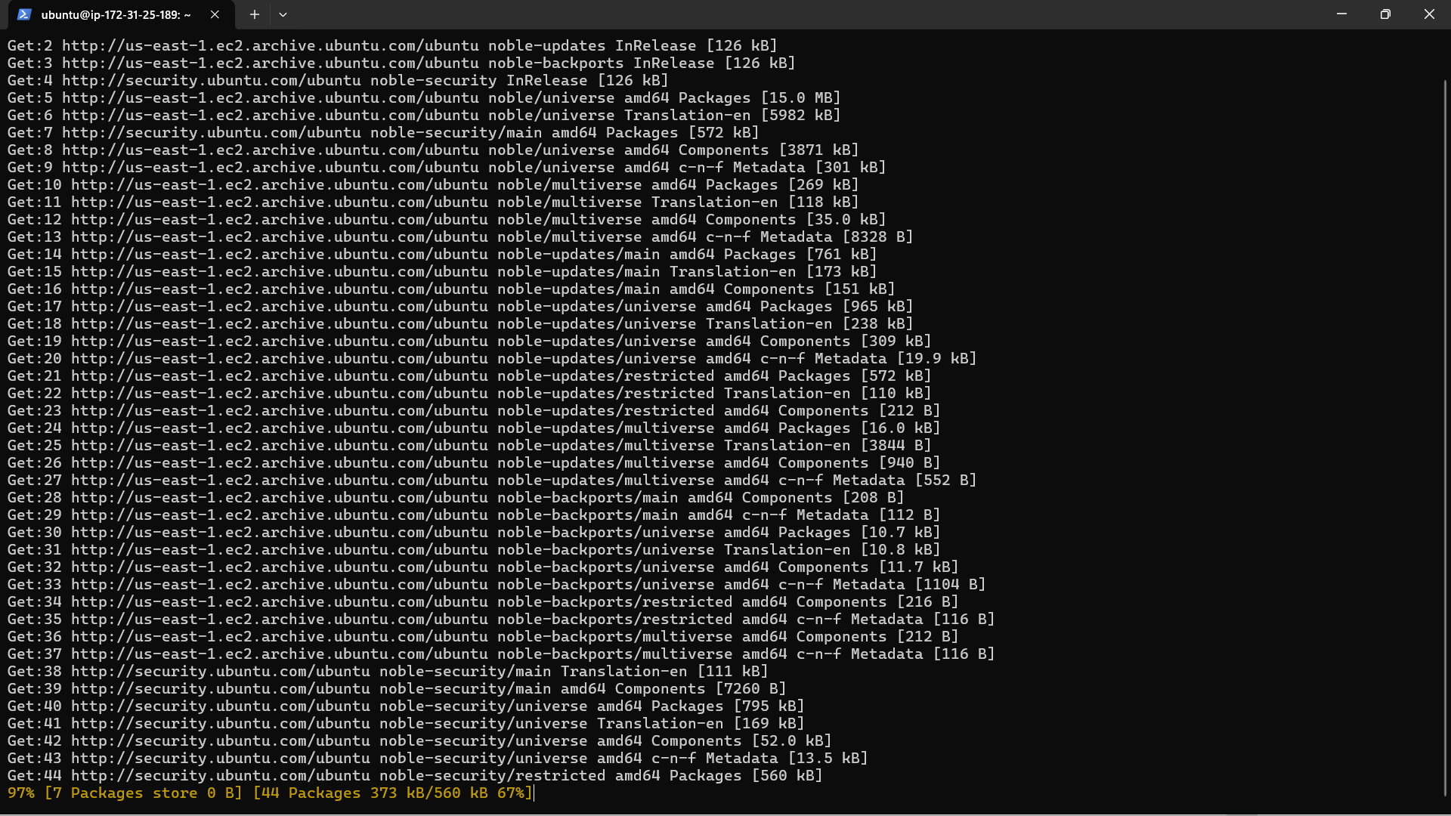

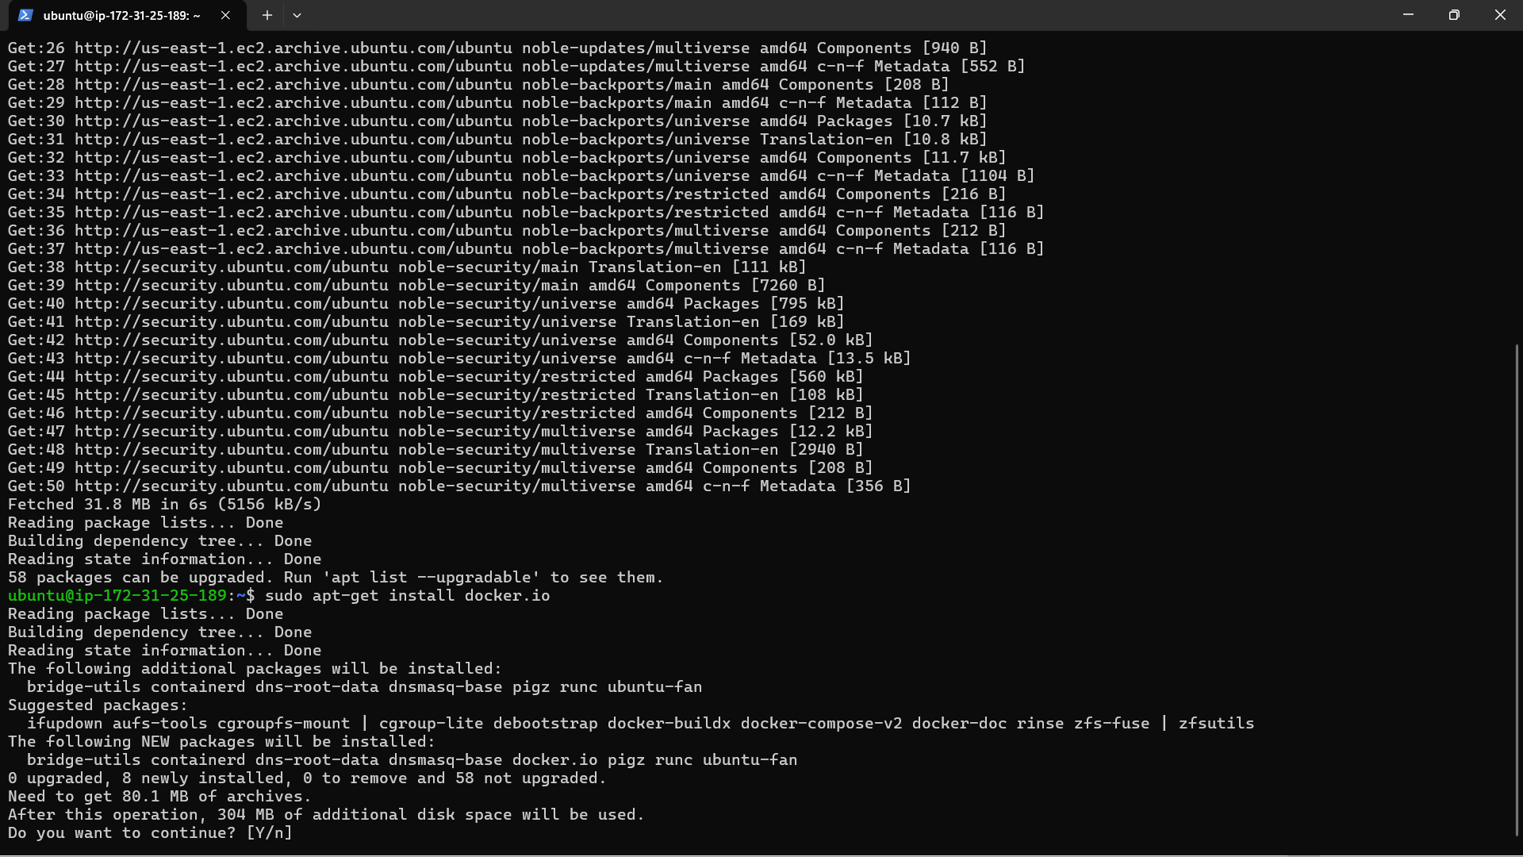

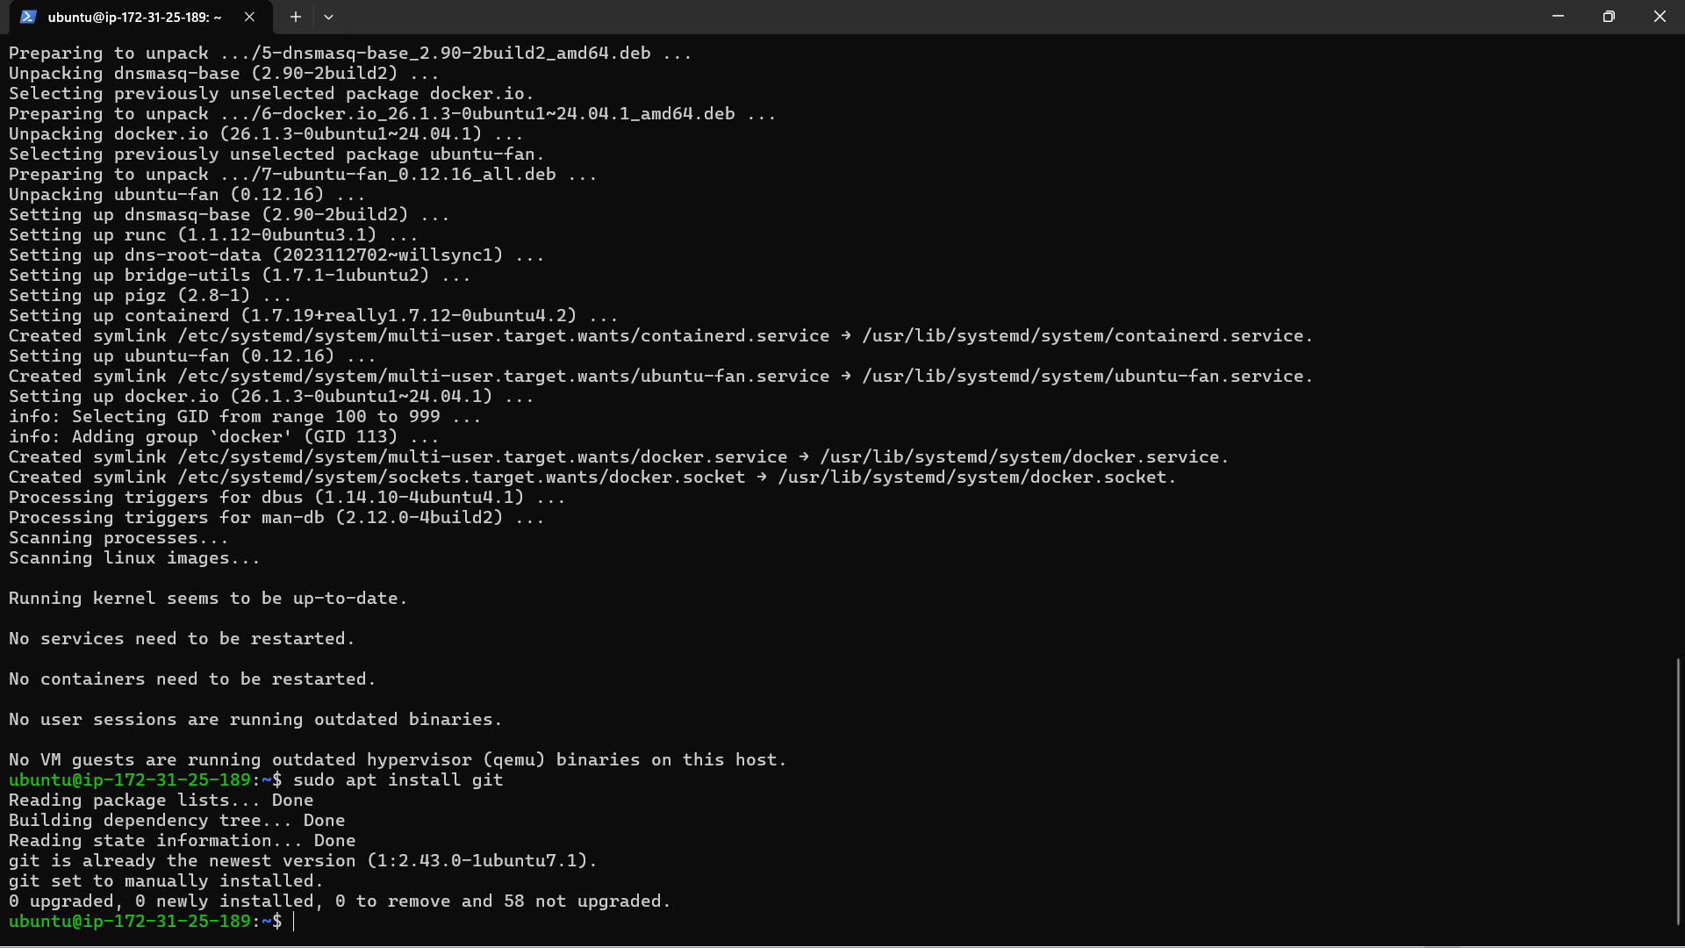

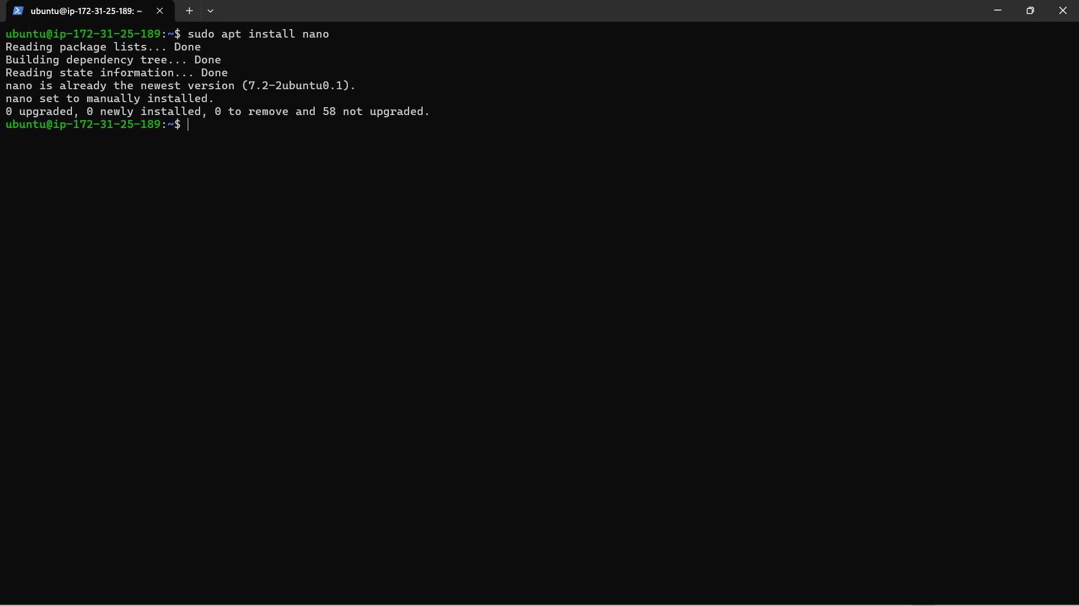

* Now, create a new index.html, create a GitHub repository and push it onto GitHub.

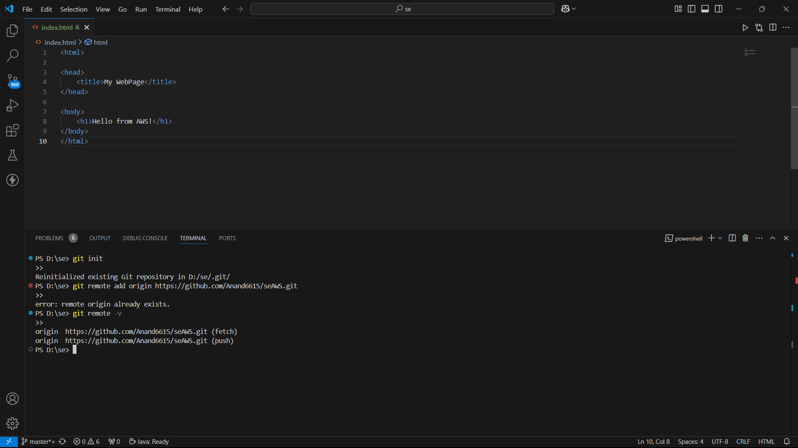

* Clone the repository inside the instance.

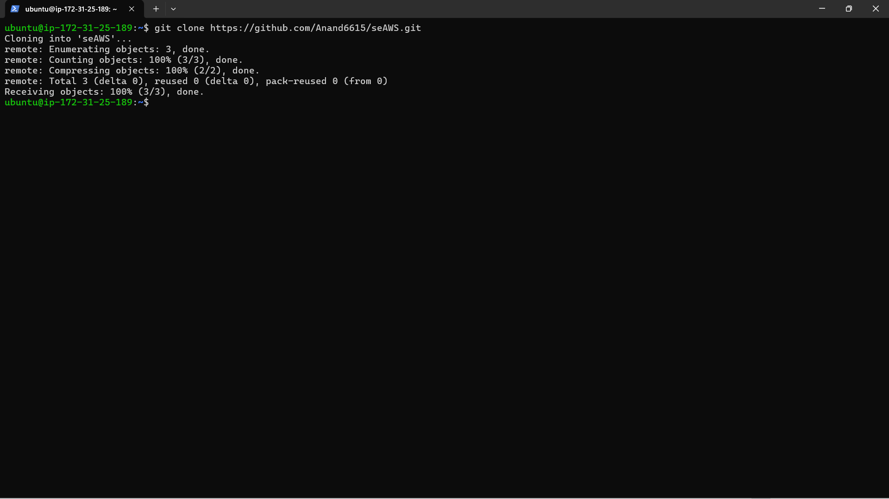

* Run nano Dockerfile to create a new Dockerfile and paste the following:

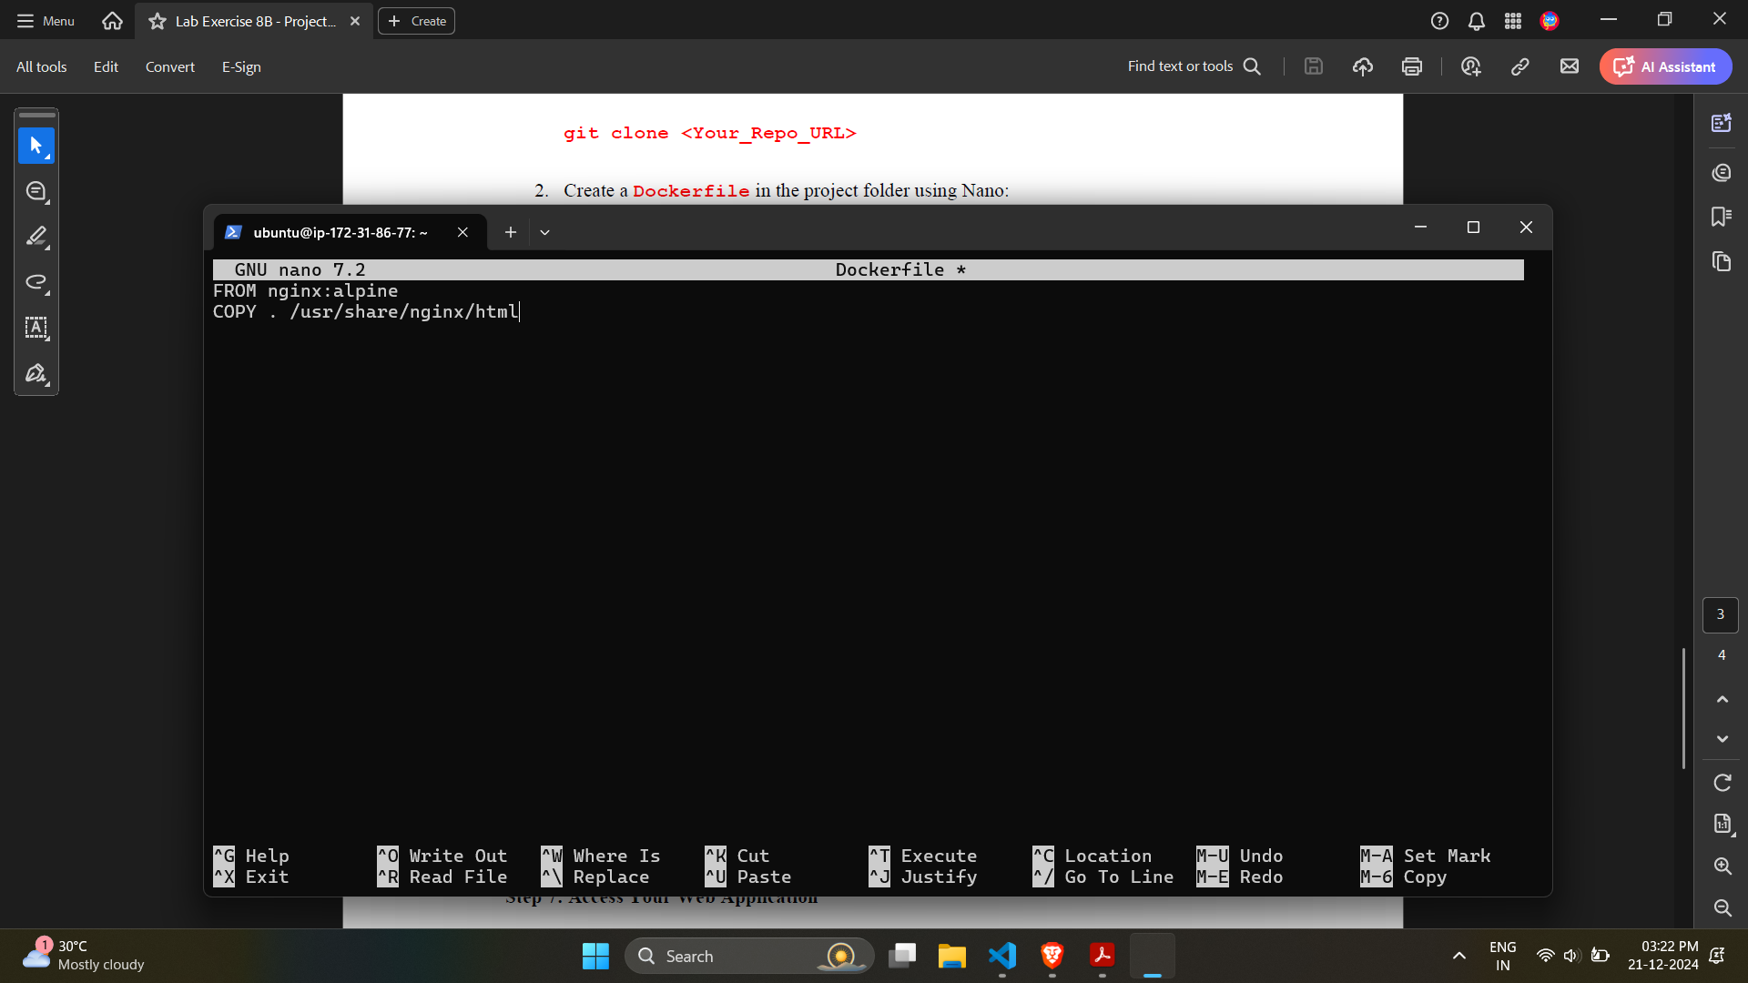

* Build the image.

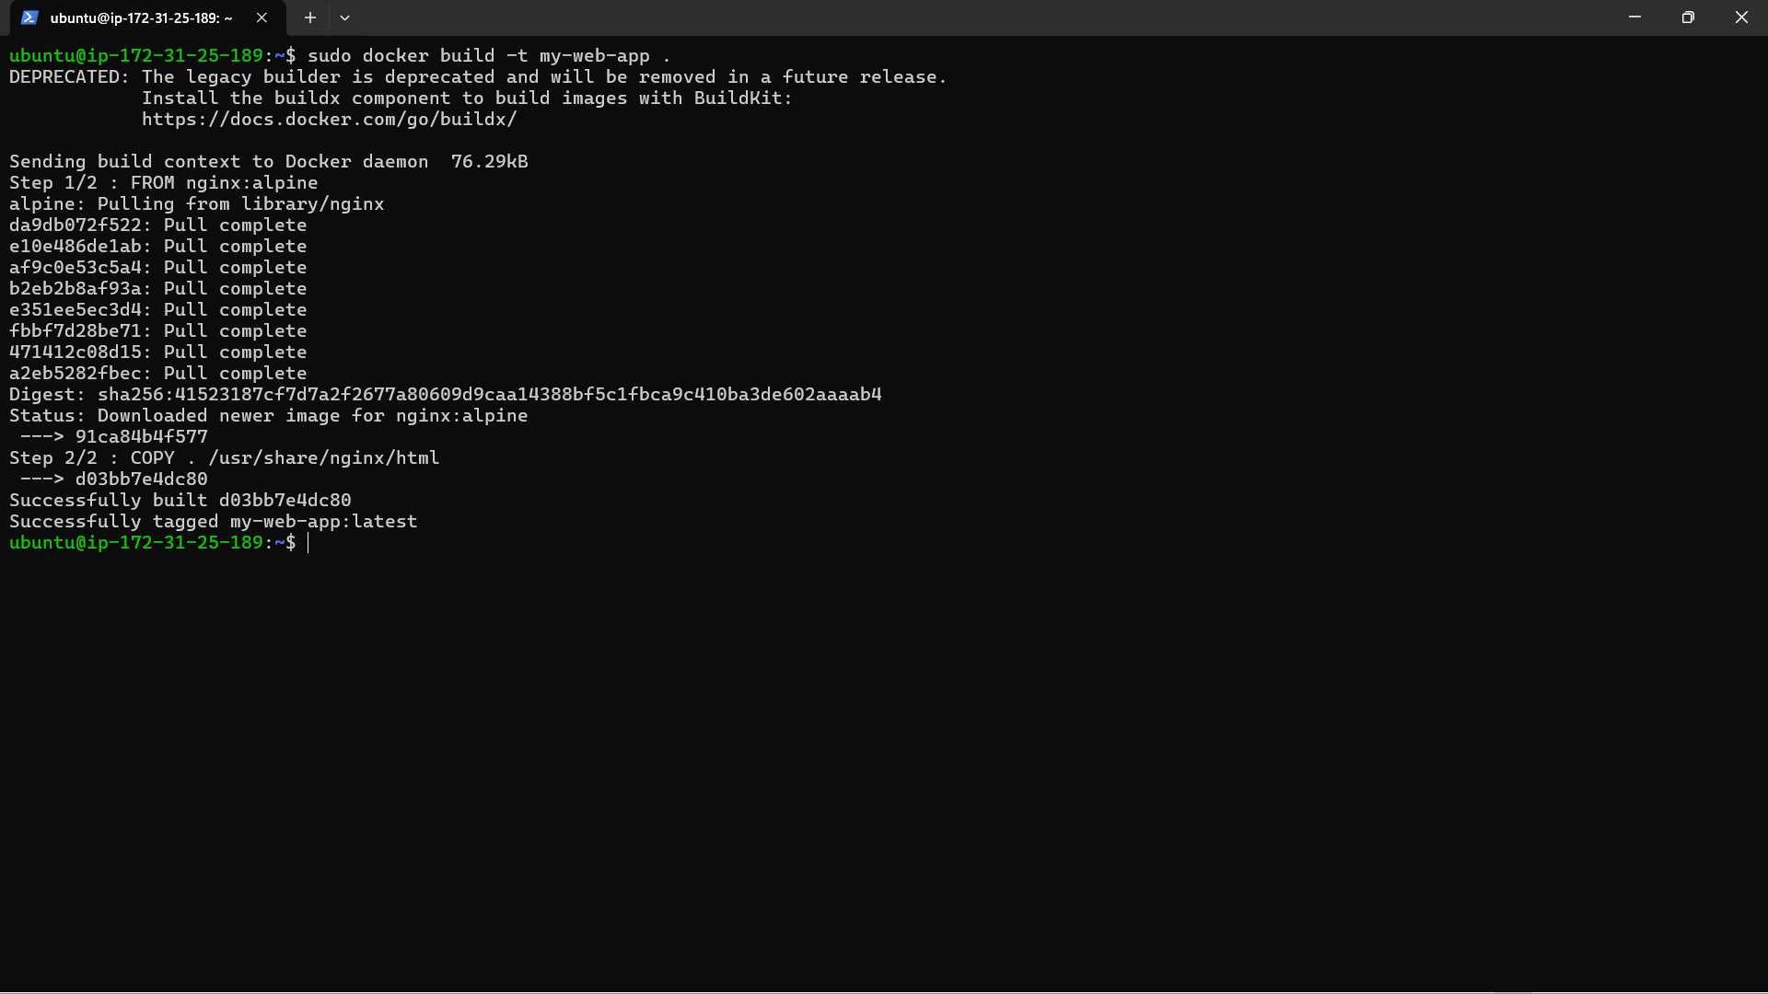

* Run the container.
* 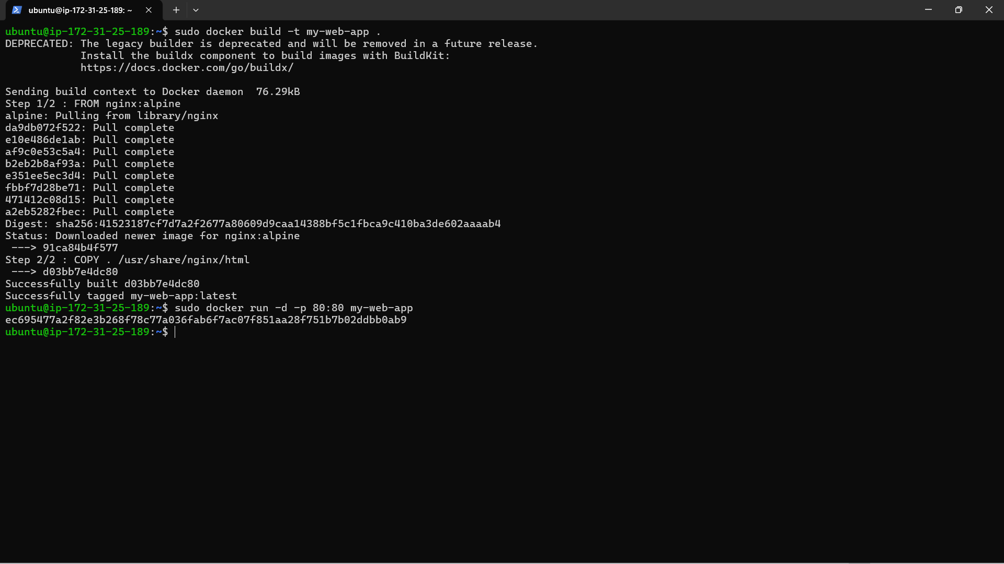
* Access the public URL from the AWS page.

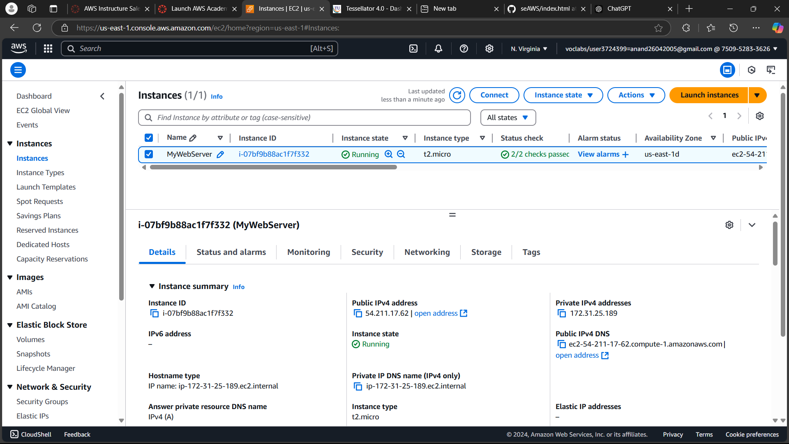

* The project is now deployed.

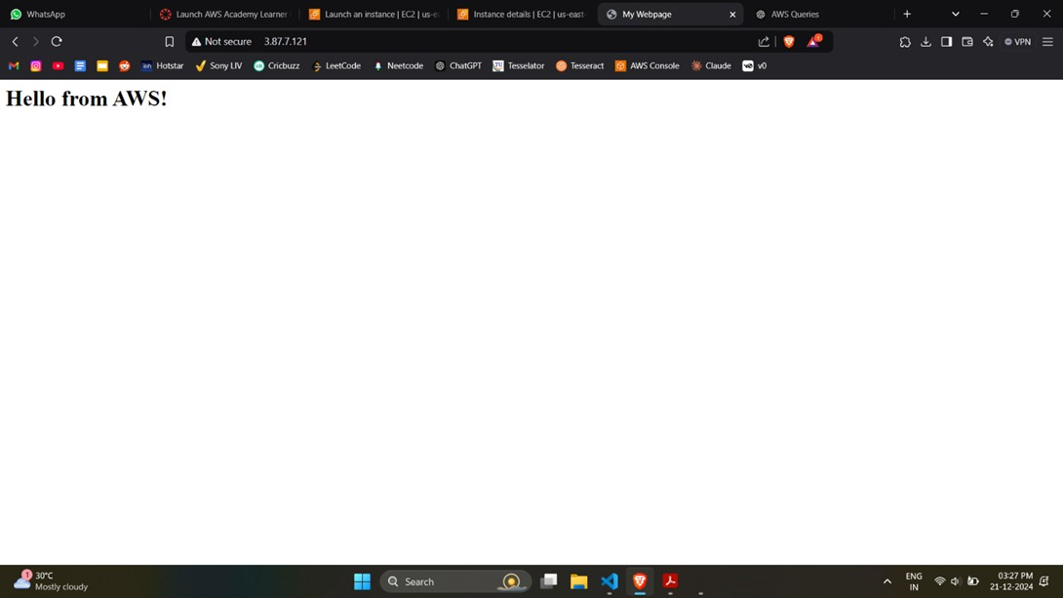

* Terminate instance to stop charges.

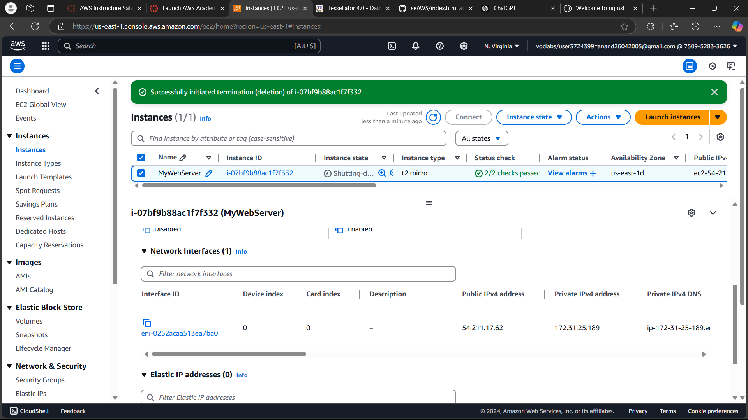

**Exercise 8C:** Maven Web Project Deployment on the AWS Cloud using EC2 Instance.

* Follow previously mentioned steps and click on Launch Instance on the EC2 instance. Give it a name and select Ubuntu as the AMI.

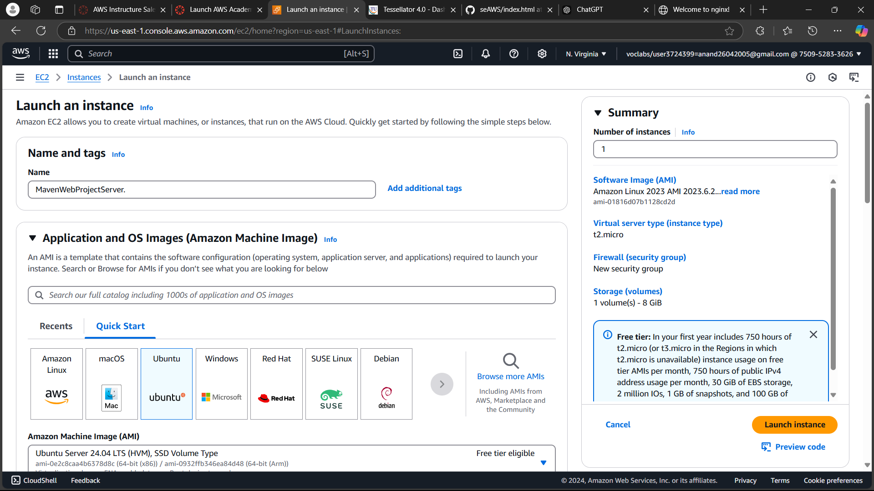

* Select t2.micro as the instance. Use the same keypair.

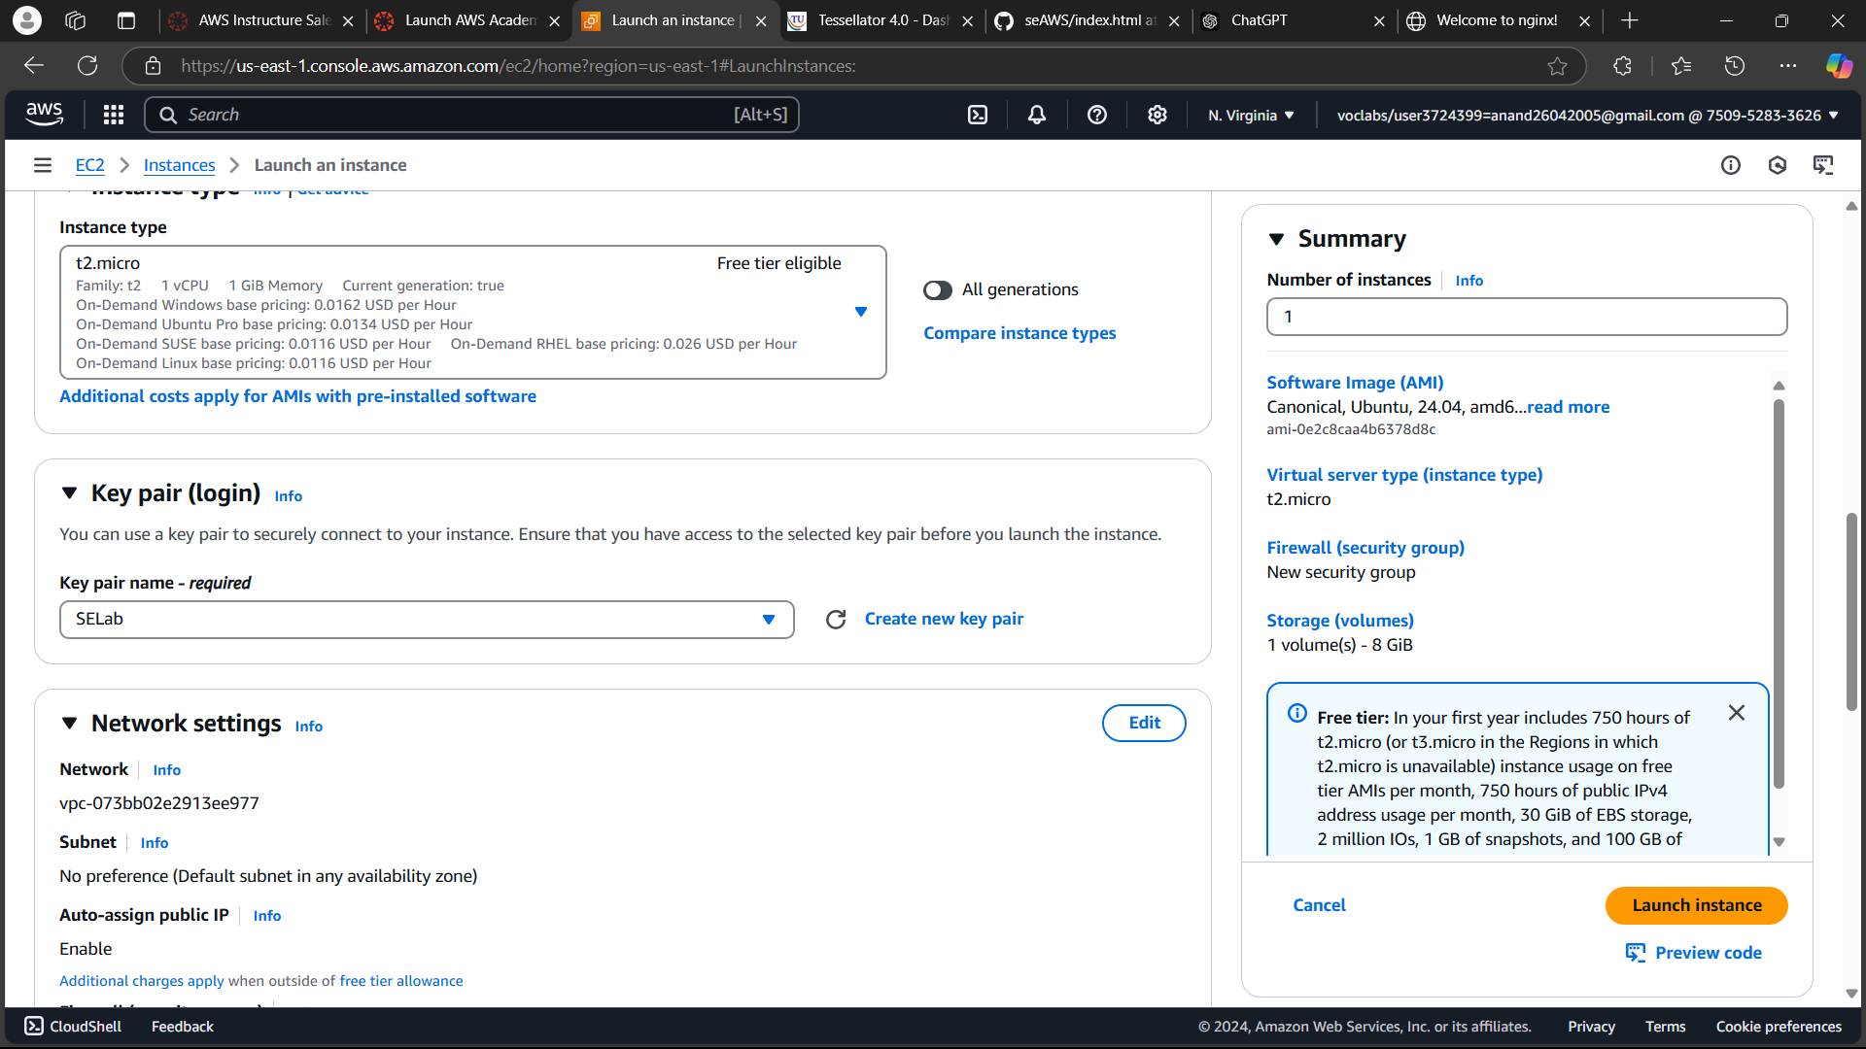

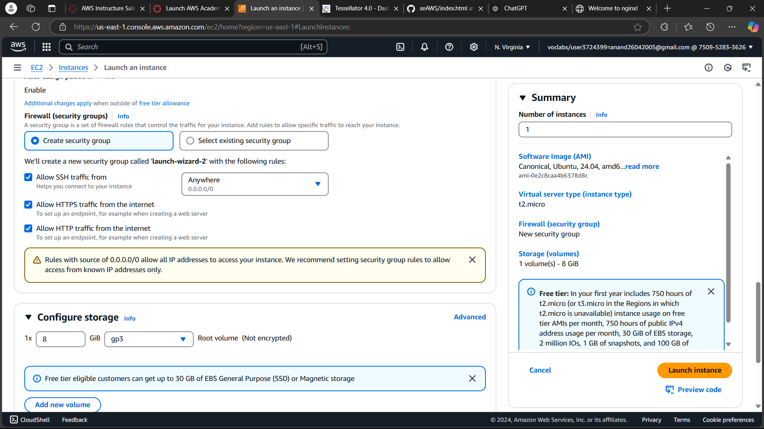

* Follow the same steps to connect to the instance.

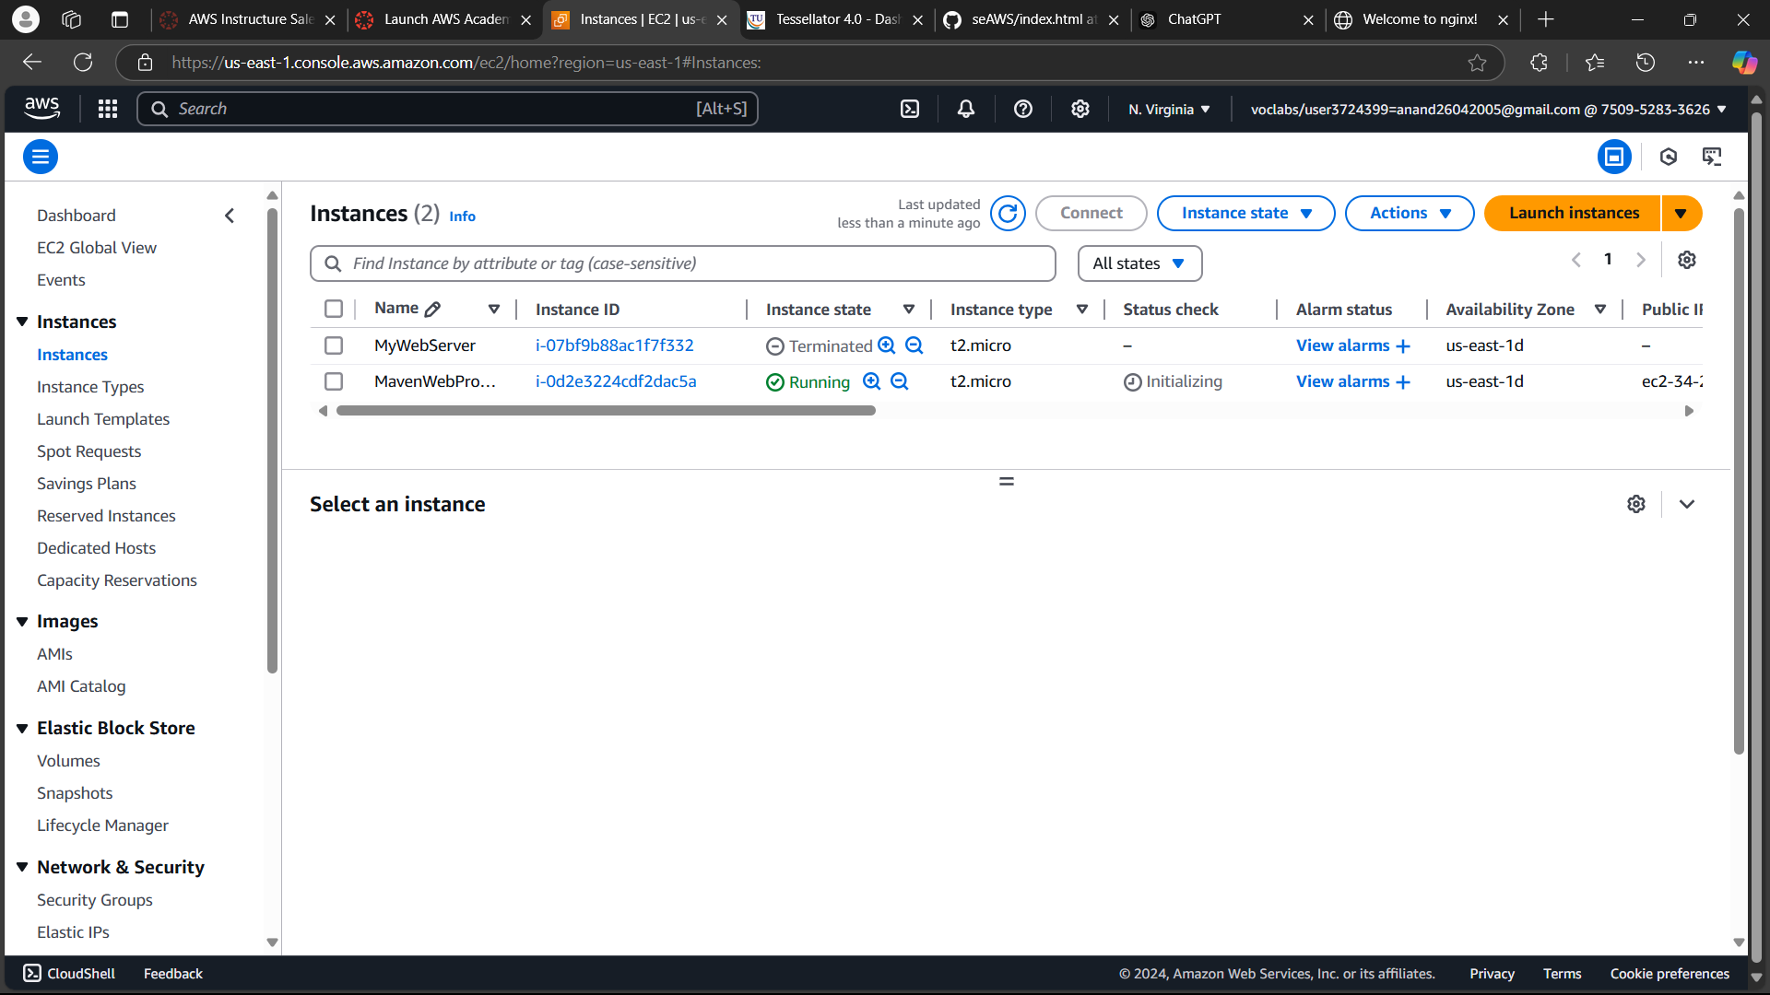

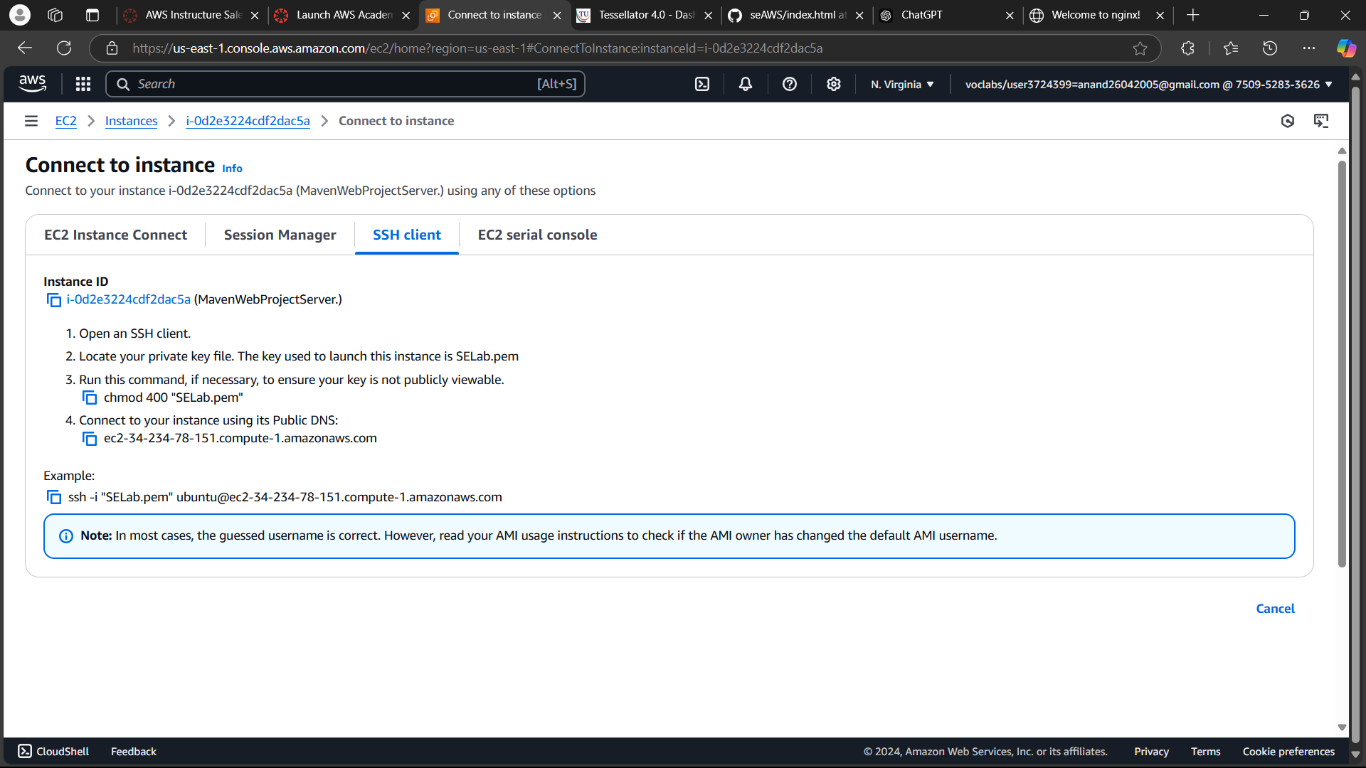

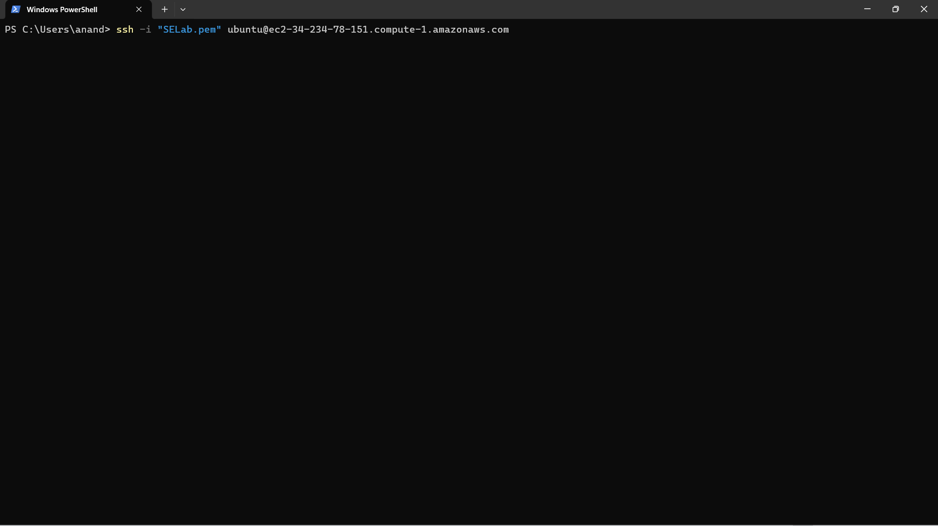

* Install docker, git, nano similarly.

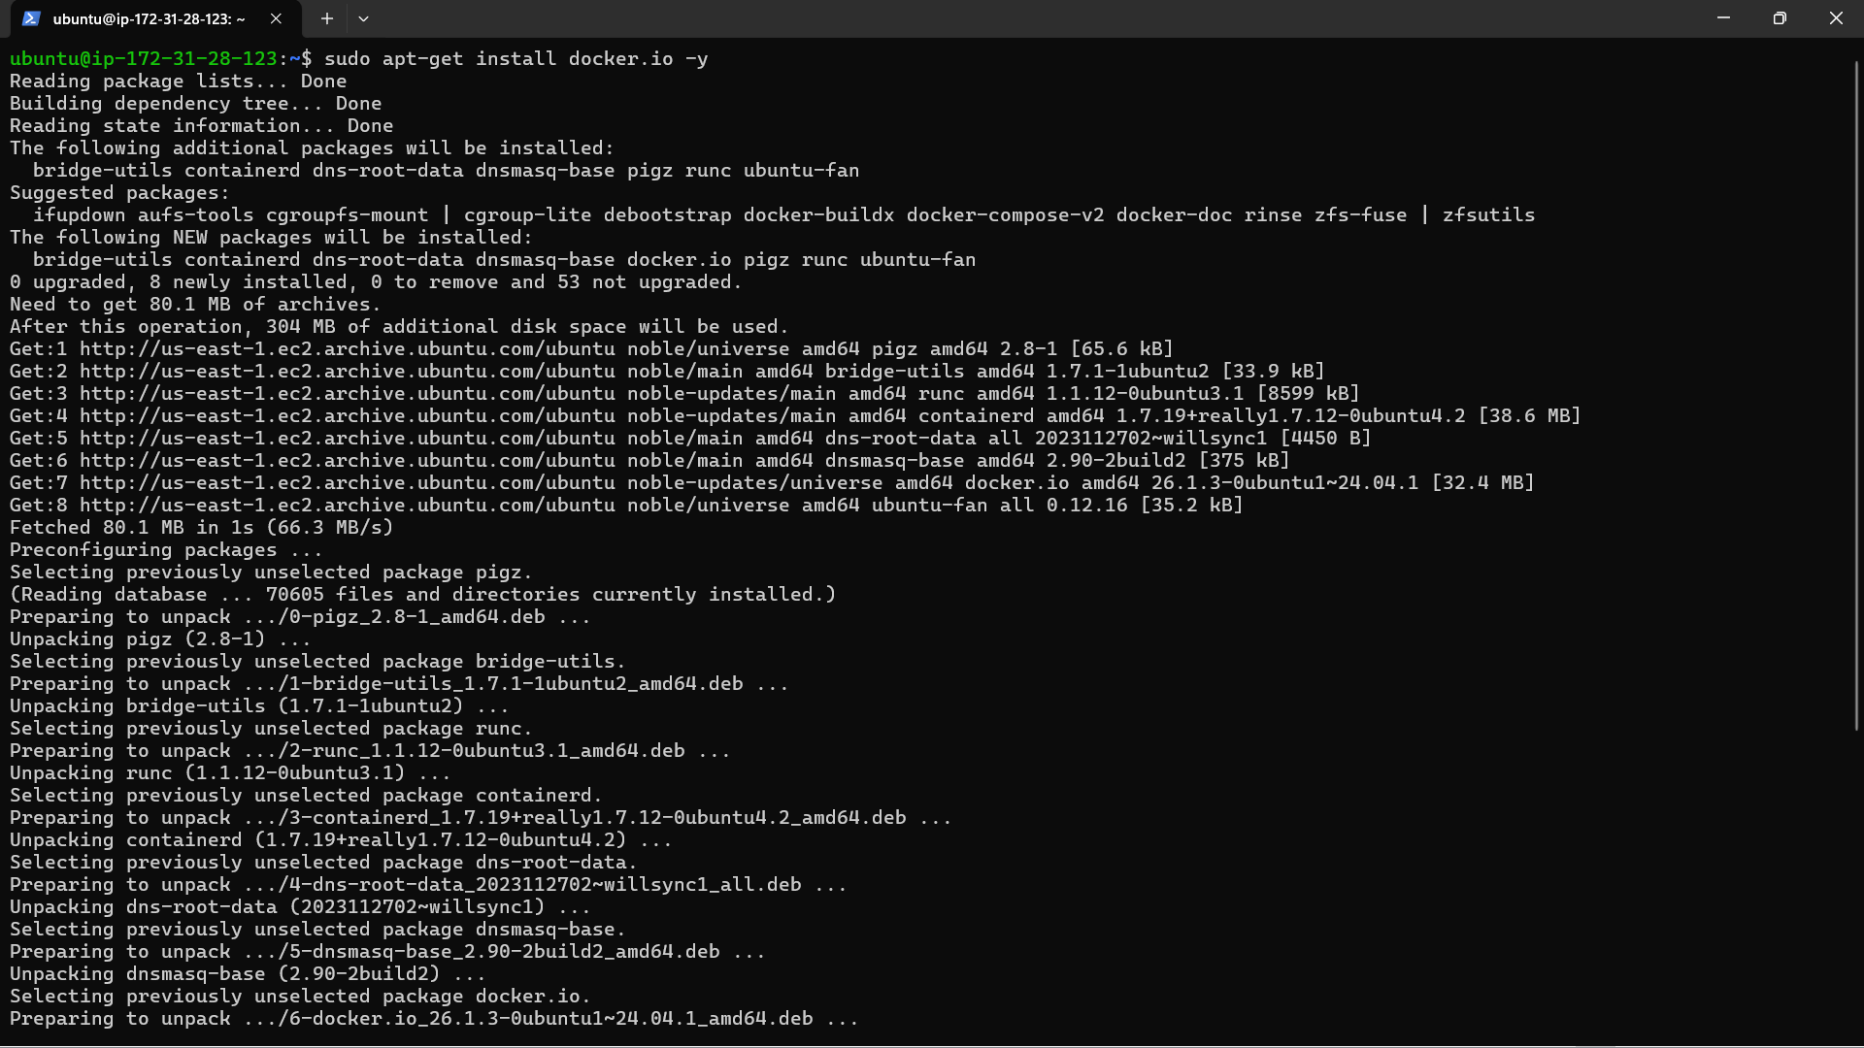

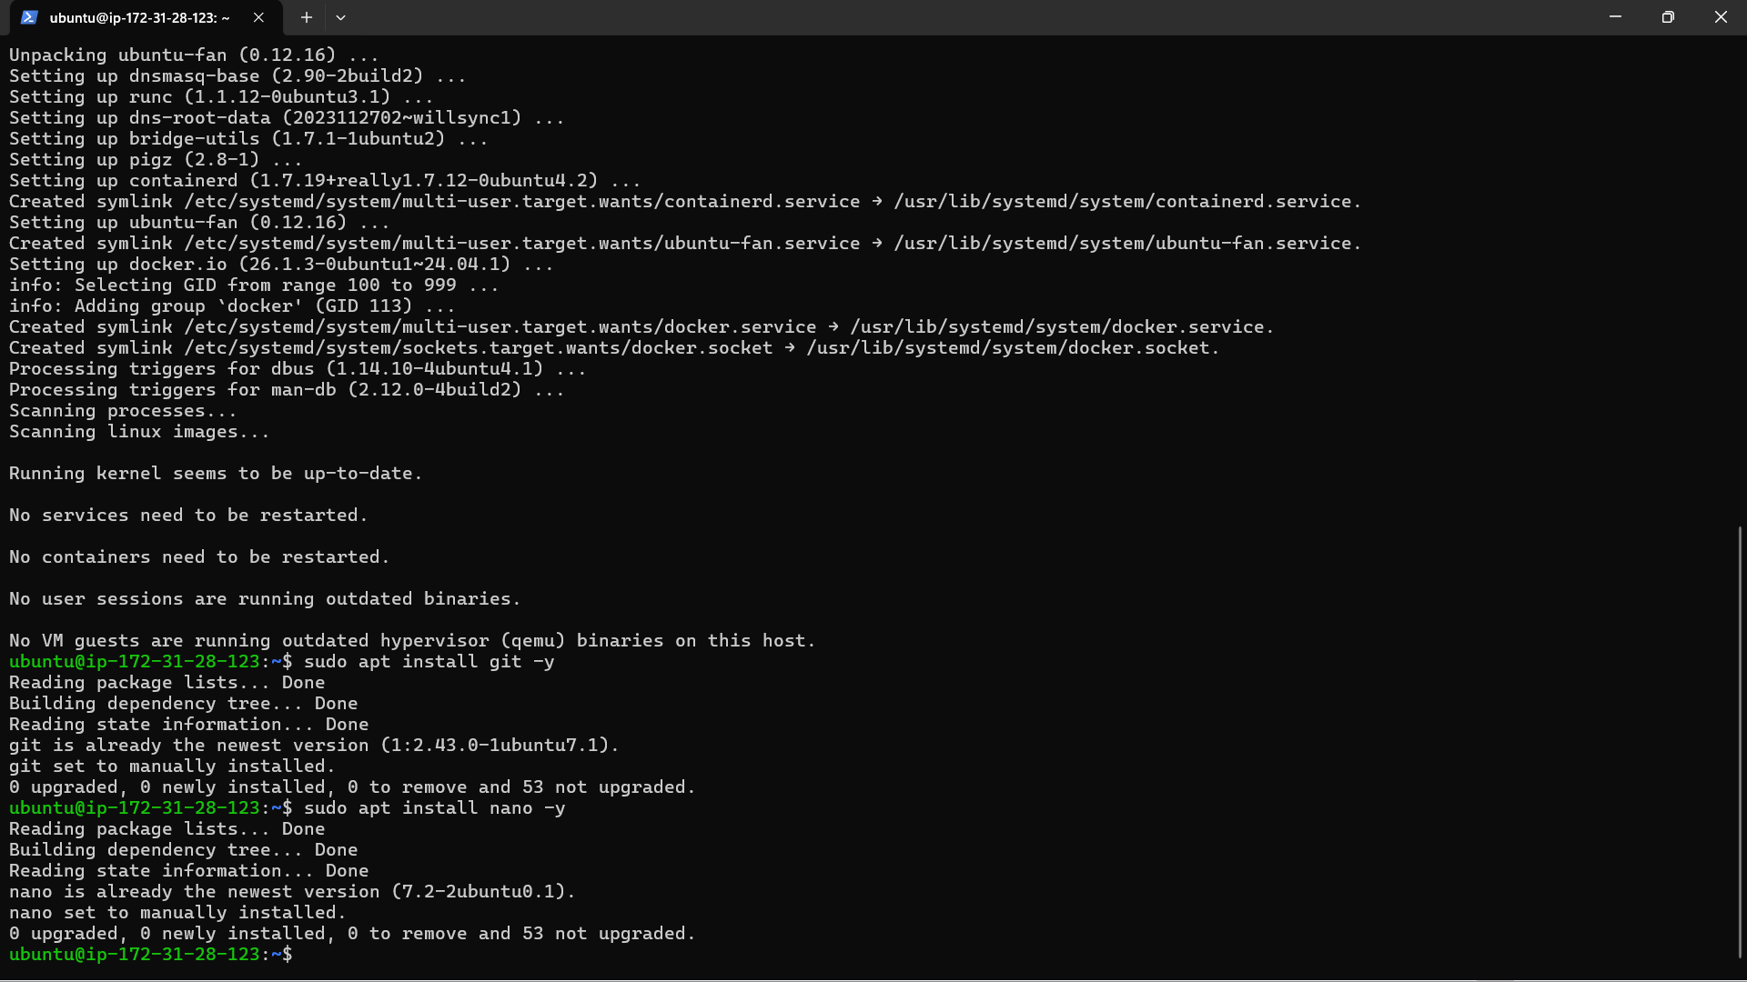

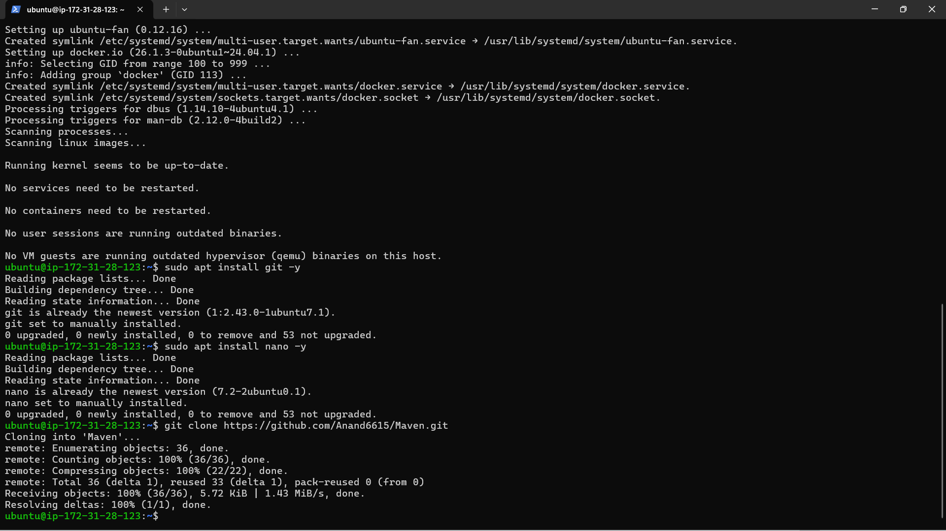

* Clone the repo for the Maven App.

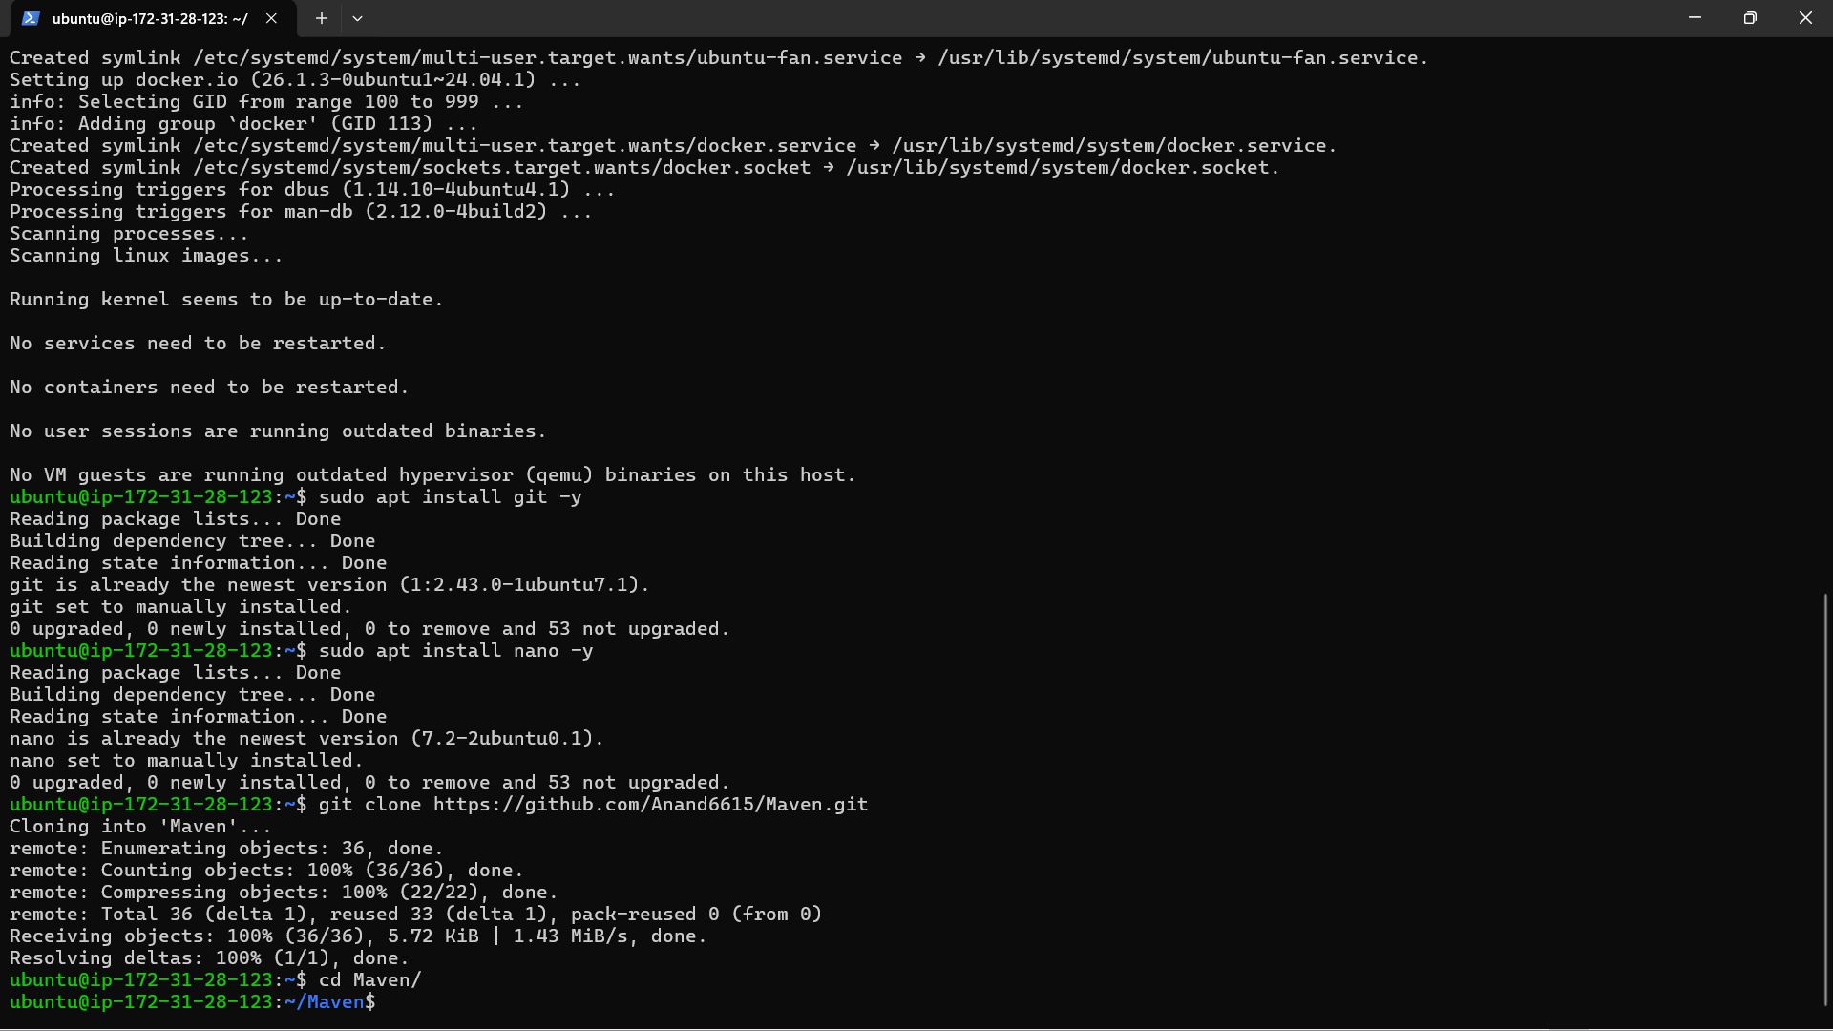

* Run nano Dockerfile and paste the following:

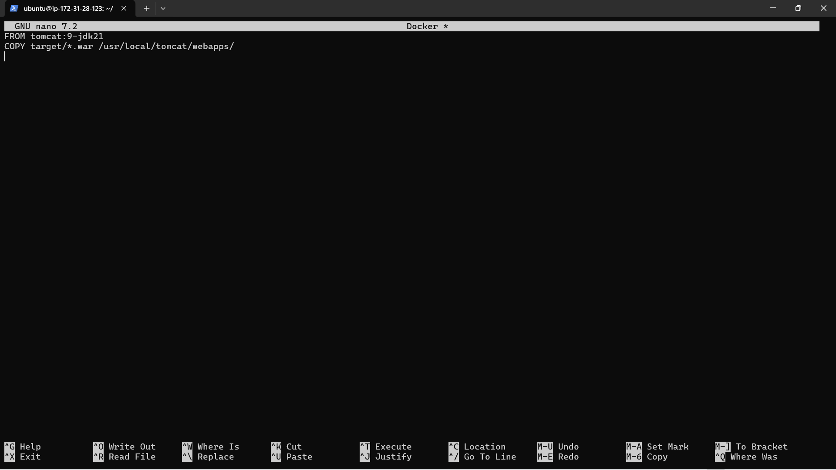

* Build the image and run the container.

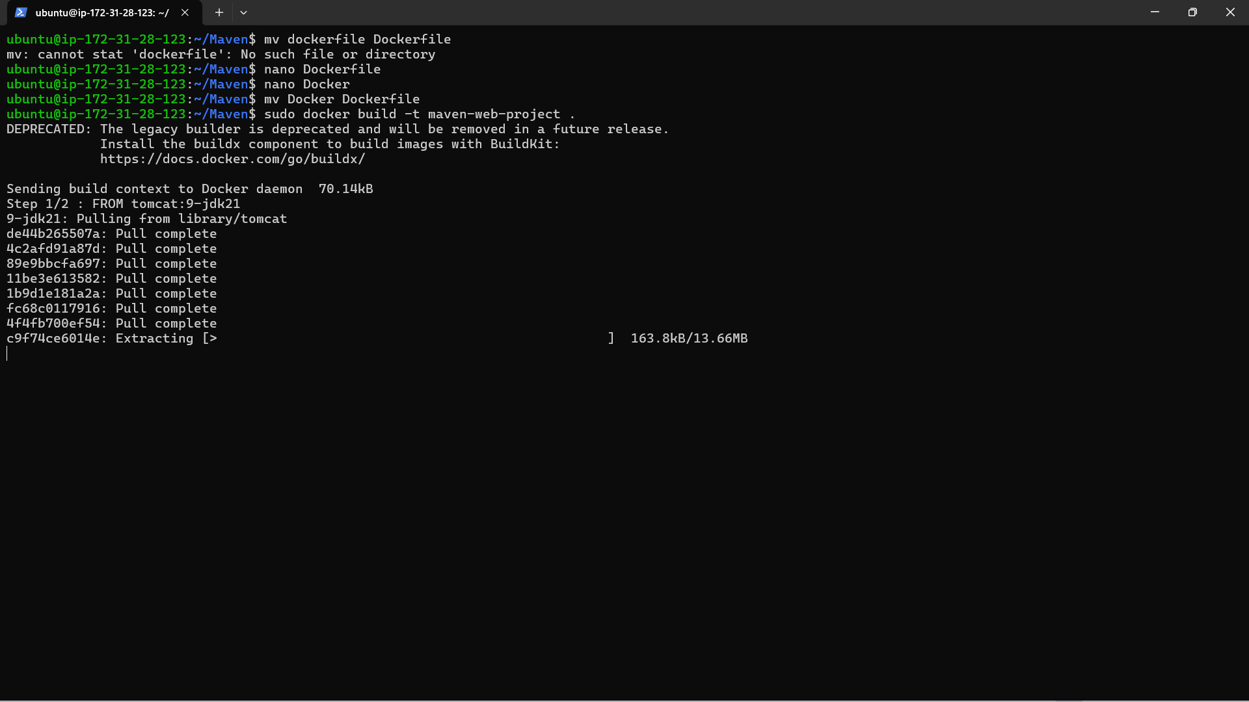

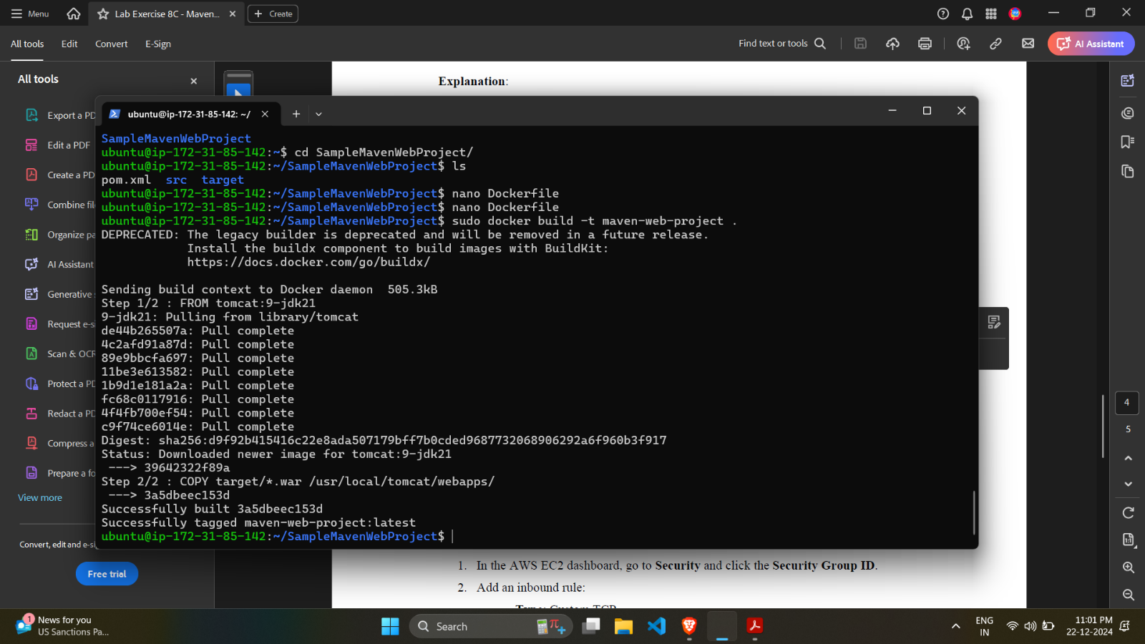

* Go to security in the instance page, and click on the security group.

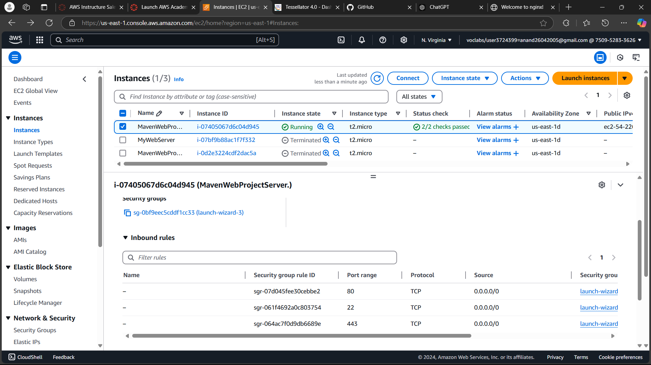

* Add an inbound rule to allow traffic at port 9090.

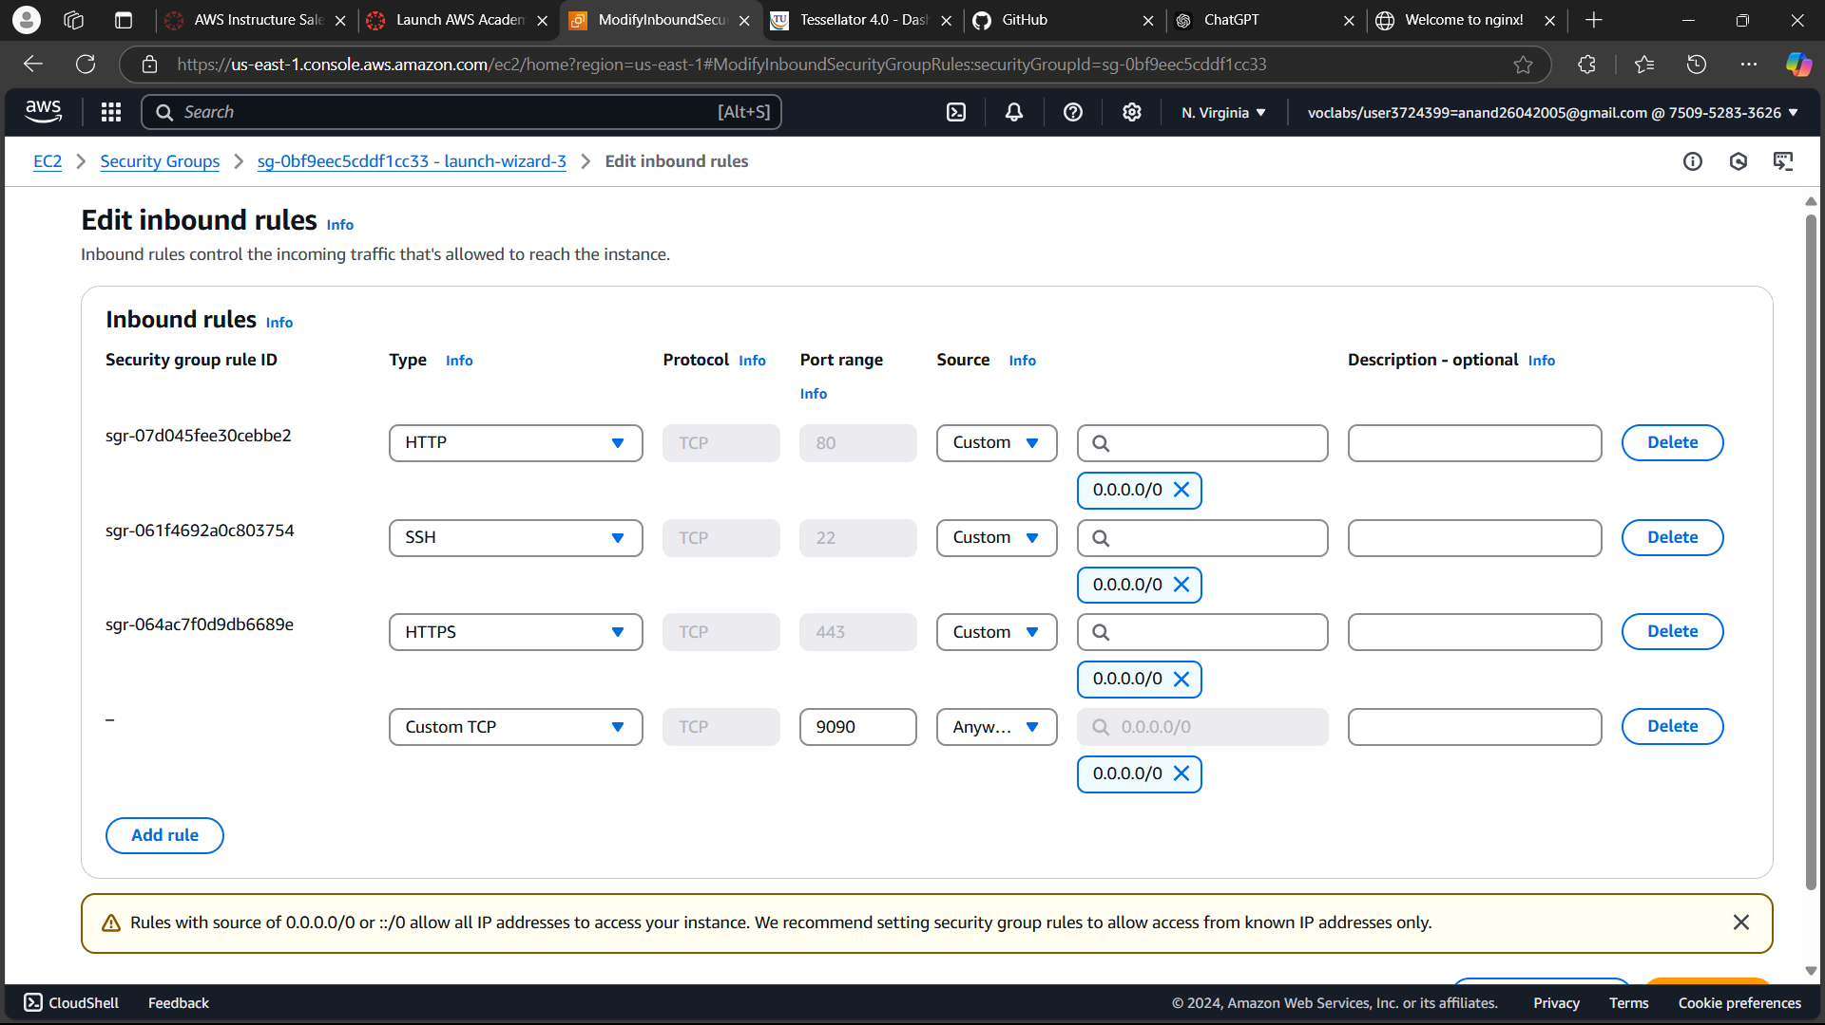

* The project should now be visible at the public ip.

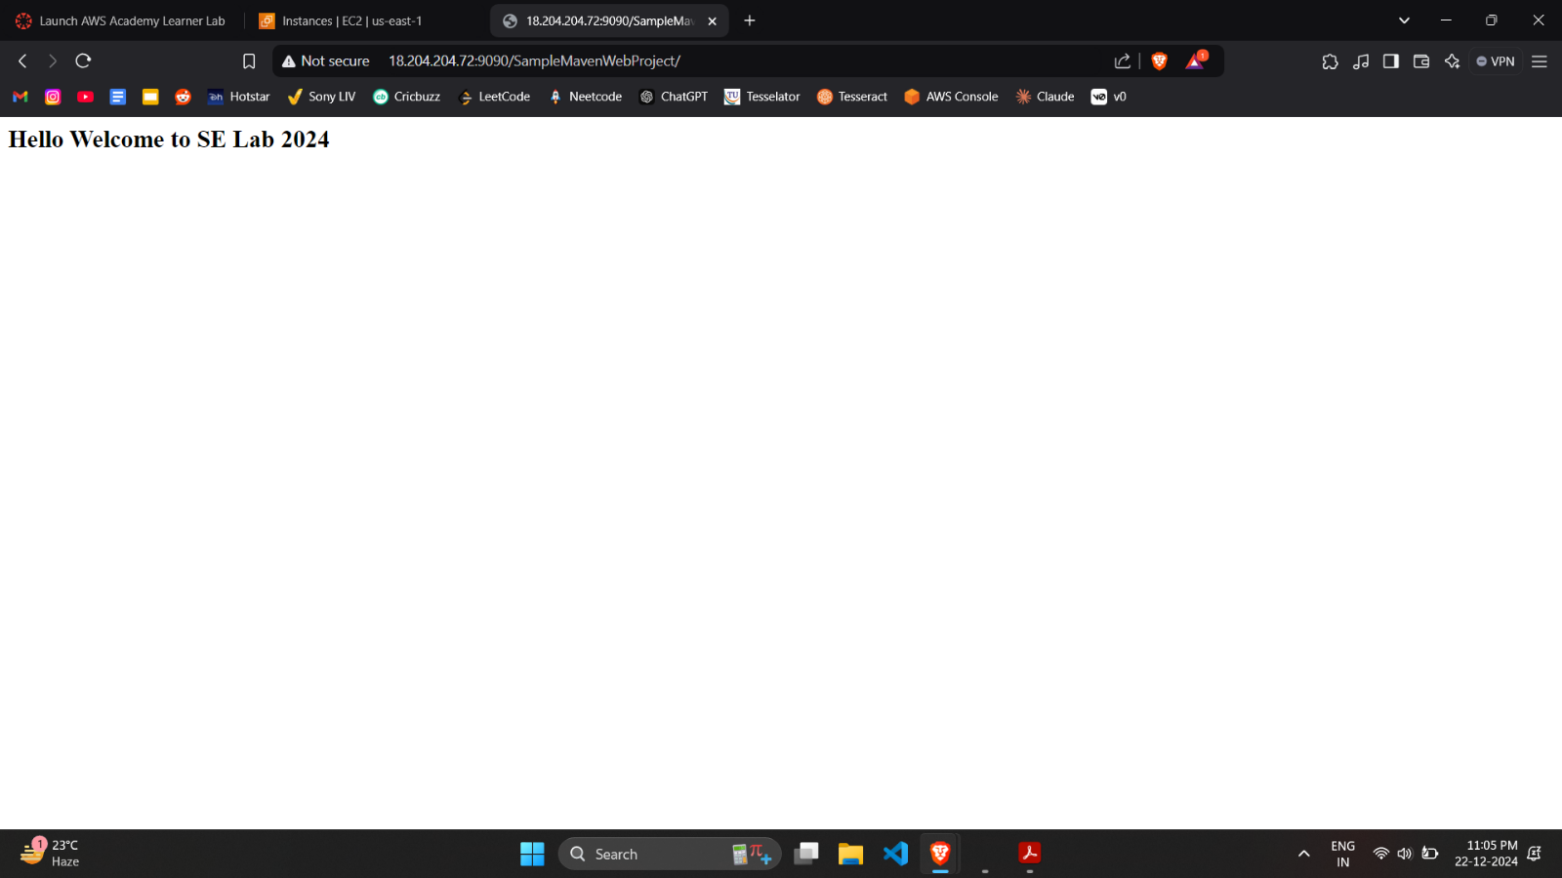

* Stop the container and terminate the instance.

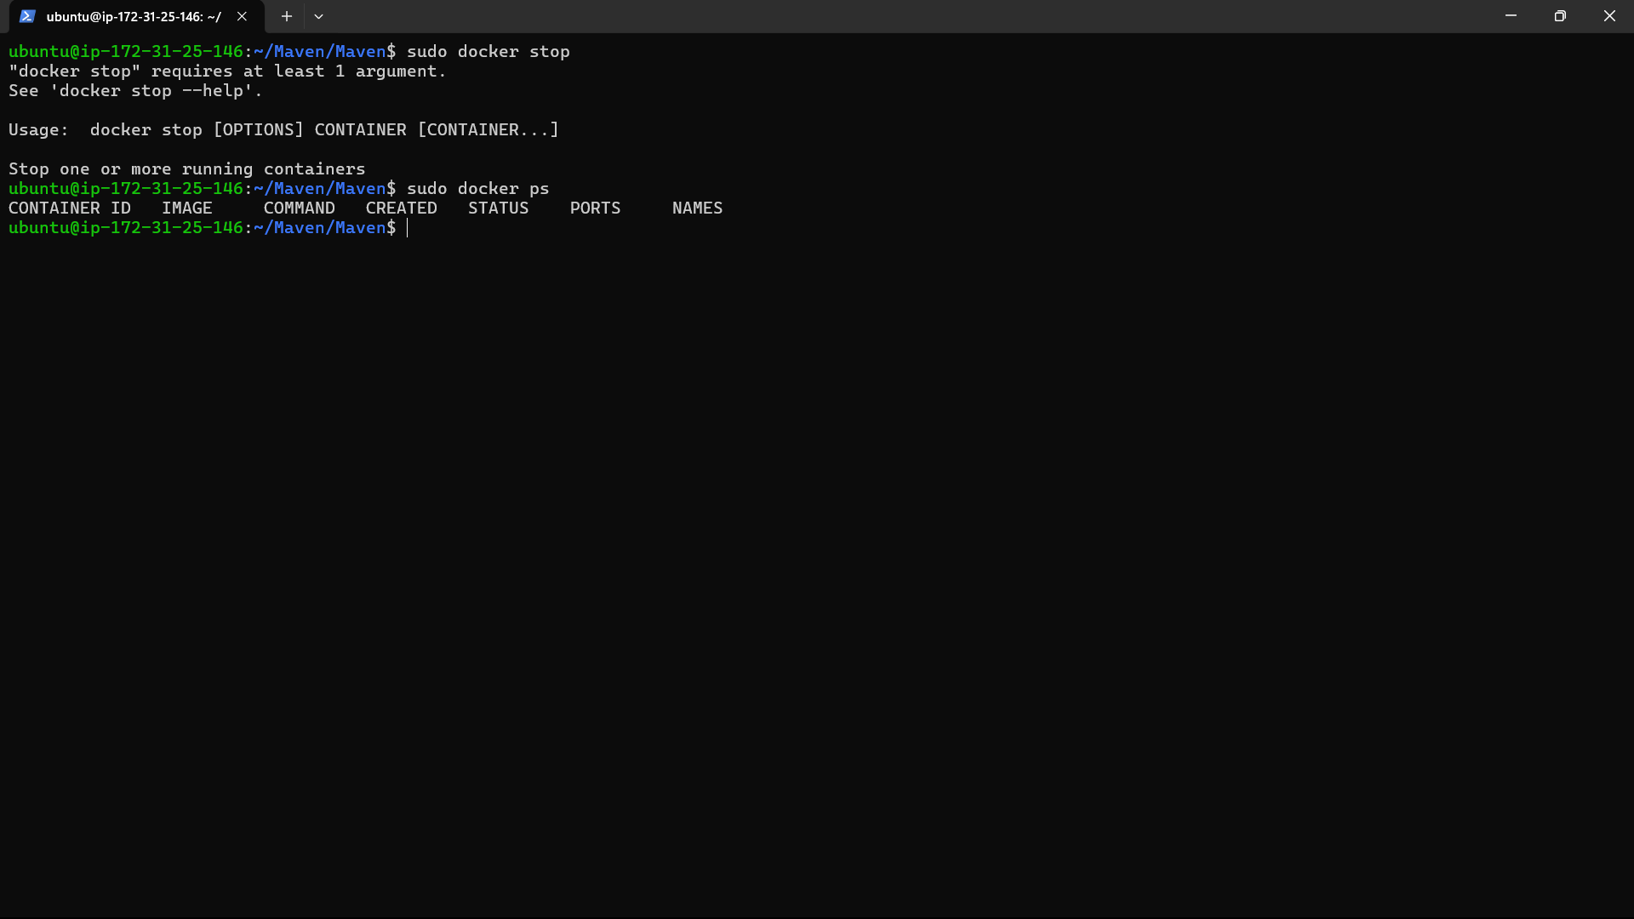

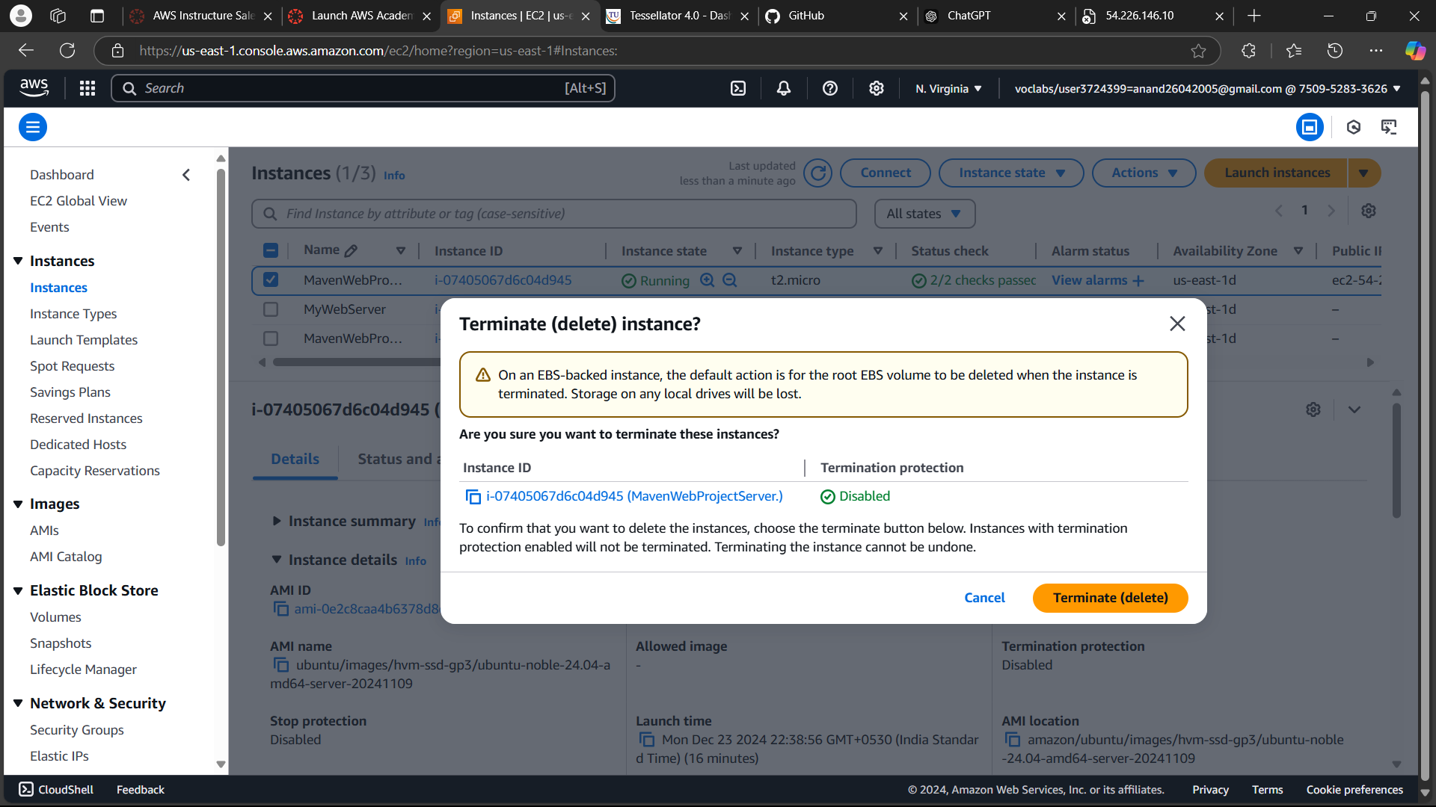

* End the lab on the Canvas page.

